DG TAXUD
Business Process Description
ICS2
Date: 15/12/2023
Doc. Version: 2.01

Document Control Information

Settings | Value
Document Title: | Business Process Description
Project Title: | ICS2
Document Author: | DG TAXUD ICS2 Project team
Project Owner: | DG TAXUD ICS2 Project team
Doc. Version: | 2.01
Sensitivity: | Basic
Date: | 15/12/2023

Document Approver(s) and Reviewer(s):
NOTE: All Approvers are required. Records of each approver must be maintained. All Reviewers in the list are considered required unless explicitly listed as Optional.
Name | Role | Action | Date
ECCG |  | Approve
RIMSCO |  | Review

Document history:
The Document Author is authorized to make the following types of changes to the document without requiring that the document be re-approved:
- Editorial, formatting, and spelling
- Clarification

To request a change to this document, contact the Document Author or Owner.
Changes to this document are summarized in the following table in reverse chronological order (latest version first).
Revision | Date | Created by | Short Description of Changes
0.5 | 27/06/2017 | DG TAXUD | Initial version
1.0 | 07/05/2018 | DG TAXUD | Updated as per review comments
1.10 | 15/10/2018 | DG TAXUD | Updated for Release 1
1.20 | 07/06/2019 | DG TAXUD | Implementing RfCs for Release 2
1.22 | 31/03/2020 | DG TAXUD | Implementing second package of RfCs for Release 2
1.23 | 19/03/2021 | DG TAXUD | The following RfC’s were implemented:  RfC200038 - R2 - AN - Notify party in Arrival notification and Control notification  RfC200039 - R2 - Timers for full risk analysis
1.30 | 30/04/2021 | DG TAXUD | RfC’s from MS CAB7, 29/01/2021 implemented.  References to data elements from previous UCC version removed.
2.00 | 30/07/2021 | DG TAXUD | RfC’s from MS CAB8, 08/07/2021 implemented.  R2 and R3 specifications incorporated.
2.01 | 15/12/2023 | DG TAXUD | The following RfC’s implemented MS CAB09, 27/04/2023:  “RfC220006 - R2 - ENS Consultation per receptacles”  “RfC220007 - R2 - Air - Notifications to be added for F25”  “RfC230001 - R3 - Rail - New ENS filing type F52 for partial master information”  “RfC230002 - R3 - Rail - New ENS filing type F53 for house level information”  “RfC230003 - R3 - Rail - New ENS filing type F54 for partial house level information”  “RfC230004 - R3 - Rail - New ENS filing type F55 for goods shipment information”

TABLE OF CONTENTS
1 Introduction 7
1.1 Purpose 7
1.2 Scope 7
1.3 Target Audience 7
1.4 Structure of this document 7
1.5 Reference and applicable documents 8
1.5.1 Reference Documents 8
1.5.2 Applicable Documents 8
1.6 Abbreviations and Acronyms 8
1.7 Business context 10
2 High level end-to-end process 12
2.1 Sub-processes 13
2.1.1 HLS001 - Register filing 13
2.1.2 HLS002 – Prepare ENS for risk analysis 17
2.1.3 HLS003 - Perform risk analysis 29
2.1.4 HLS004 - Process arrival of the means of transport 43
2.1.5 HLS005 – Process presentation and controls 49
2.1.6 HLS006 – Amend ENS filing 54
2.1.7 HLS007 – Invalidate filing 59
2.2 Events 64
2.2.1 HLE01 – ENS filing received 64
2.2.2 HLE02 – Amendment of ENS filing received 64
2.2.3 HLE03 – Invalidation request received 64
2.2.4 HLE04 – 200 days timer expiry 64
2.2.5 HLE05 – ENS filing invalidated 64
2.2.6 HLE06 – Entry process completed 64
2.2.7 HLE07 – Arrival notification received 64
2.2.8 HLE08 – Arrival notification processed 64
2.2.9 HLE09 – Goods presented 65
2.2.10 HLE10 – Goods presented and controlled 65
3 Main entities & State transitions 66
3.1 State transition diagram 66
4 Annex 68
4.1 ENS filing types 68

TABLE OF FIGURES
Figure 1: ICS2 Business context 10
Figure 2: ICS2 High level end-to-end process 12
Figure 3: HLS001 Register filing sub-process 14
Figure 4: HLS002 Prepare ENS for risk analysis sub-process 18
Figure 5: HLS003 Perform risk analysis sub-process 31
Figure 6: HLS004 Process arrival of the means of transport sub-process 44
Figure 7: HLS005 Process presentation and controls sub-process 50
Figure 8: HLS006 Amend ENS filing sub-process 55
Figure 9: HLS007 Invalidate filing sub-process 60
Figure 10: Main entities 66
Figure 11: State transition example 66
Figure 12: State transition diagram 67

TABLE OF TABLES
Table 1: Reference documents 8
Table 2: Applicable documents 8
Table 3: Abbreviations and acronyms 9

Introduction

Purpose
This document provides business process description of the ICS2.
From the processes description perspective, the basic principle is to draft the business processes and their descriptions at two levels, high level end-to-end process overview, and at the level of the sub-processes. These two levels will keep ‘system agnostic’ approach. For this reason a deviation from the DG TAXUD BPM methodology was made and a new BPM level 3.5 was introduced.
The aim of this document is to bring forward sufficient level of descriptions to support the understanding of the end-to-end business processes.

Scope
This document describes:
- the business context of the ICS2,
- the high level end-to-end business process,
- sub-processes, and
- main entities and their state transitions.

Target Audience
The intended audience for this document are the representatives of the Member States.

Structure of this document
The present document contains the following chapters:
- Chapter 1 – Introduction: describes the scope and the objectives of the document;
- Chapter 2 – High level end-to-end process: describes the ICS2 high level end-to-end process and underlying sub-processes, their tasks and events;
- Chapter 3 – Main entities and state transitions: describes the entities and provides a state transition diagram;
- Annex – provides a list of the ENS filing types.

Reference and applicable documents

Reference Documents
Ref. | Title | Reference | Version | Date
R01 | Regulation (EU) No 952/2013 of the European Parliament and of the Council of 9 October 2013 laying down the Union Customs Code |  |  | 9/10/2013
R02 | Commission Delegated Regulation (EU) 2015/2446 of 28 July 2015 supplementing Regulation (EU) No 952/2013 of the European Parliament and of the Council as regards detailed rules concerning certain provisions of the Union Customs Code |  |  | 28/07/2015
R03 | Commission Implementing Regulation (EU) 2015/2447 of 24 November 2015 laying down detailed rules for implementing certain provisions of Regulation (EU) No 952/2013 of the European Parliament and of the Council laying down the Union Customs Code |  |  | 24/11/2015
Table 1: Reference documents

Applicable Documents
Ref. | Title | Reference | Version | Date
A01
Table 2: Applicable documents

Abbreviations and Acronyms
For a better understanding of the present document, the following table provides a list of the principal abbreviations and acronyms used.
Abbreviation/Acronym | Definition
AEO | Authorised Economic Operator
AWB | Air Waybill
BoL | Bill of Lading
CFSS | Common Functional System Specifications
COFE | Customs Office of First Entry
CRC | Common Risk Criteria
CRMS2 | Customs Risk Management System 2
DNL | Do Not Load
ENS | Entry Summary Declaration
EO | Economic Operator
EORI | Economic Operator Registration and Identification
e-RA | e-Risk Analysis
EU | European Union
HAWB | House Air Waybill
HBoL | House Bill of Lading
HRCM | High Risk Cargo and Mail
ICS2 | Import Control System 2
IMO | International Maritime Organization
IMS | Involved Member State
MAWB | Master Air Waybill
MBoL | Master Bill of Lading
MRN | Master Reference Number
MS | Member State
NVOCC | Non-Vessel Operating Common Carrier
PLACI | Pre-loading Air Cargo Information
RfI | Request for Information
RfS | Request for Screening
RMS | Responsible Member State
TARIC | Integrated Tariff of European Union
UCC | Regulation (EU) No 952/2013 of the European Parliament and of the Council of 9 October 2013 laying down the Union Customs Code
UCC DA | Commission Delegated Regulation (EU) 2015/2446 of 28 July 2015 supplementing Regulation (EU) No 952/2013 of the European Parliament and of the Council as regards detailed rules concerning certain provisions of the Union Customs Code
ULK | Unique Linking Key
Table 3: Abbreviations and acronyms

Business context

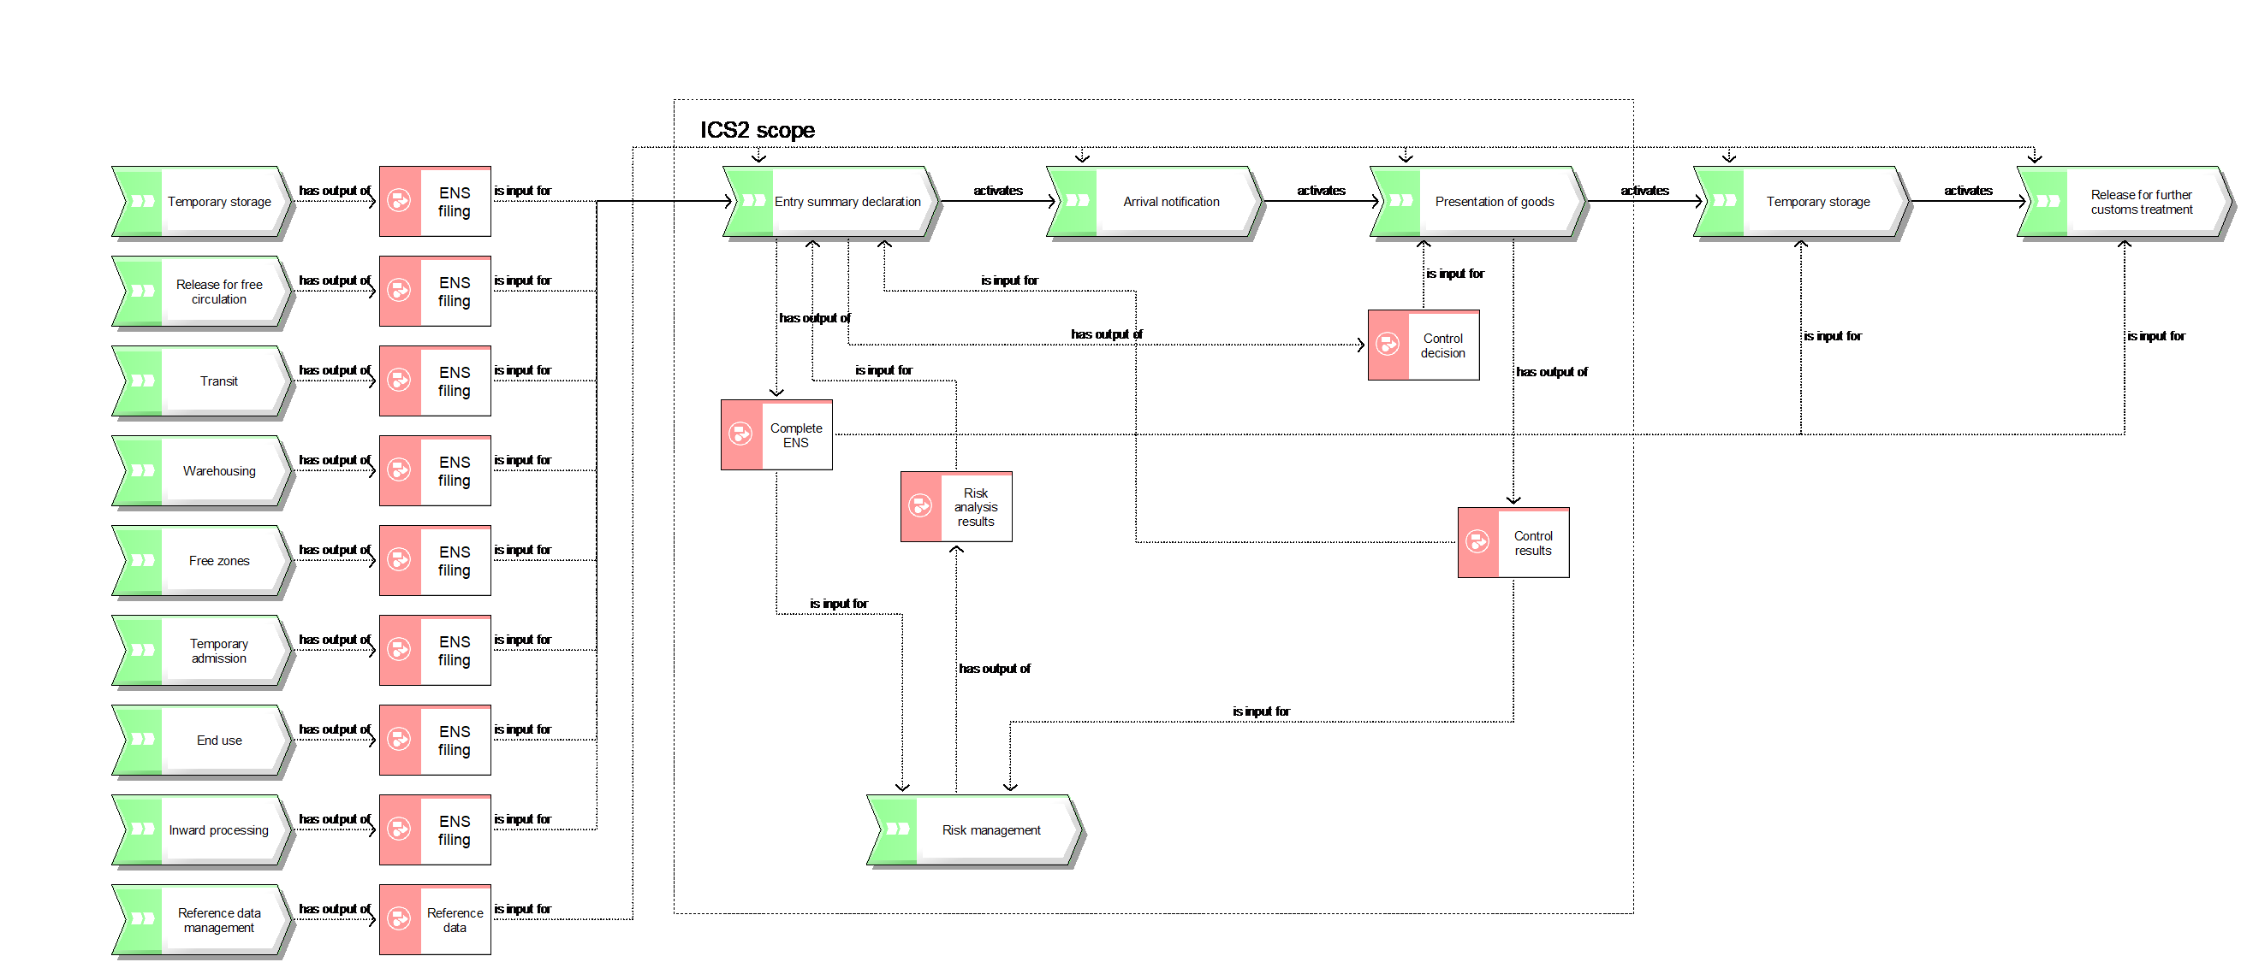
Figure 1: ICS2 Business context

The purpose of the above figure is to present ICS2 business context and depict different business interfaces between ICS2 components and other customs processes (see Figure 1).
Entry of the goods into the EU can be described as a 5 step process, consisting of the lodgement of the Entry summary declaration (ENS), notification of the arrival of the means of transport, presentation of goods, temporary storage and placing the goods under a customs procedure.
ICS2 business process scope covers 3 steps out of 5: lodgement of the ENS, notification of the arrival of the means of transport and presentation of goods. In addition, this process interacts with other customs processes in the global customs context.
First of all, the ENS filing can be lodged not only directly but also be an input from other customs processes. Art. 130 of UCC stipulates that ENS particulars can be combined with a declaration for temporary storage or a customs declaration for release for free circulation, transit, warehousing, free zones, temporary admission, end use and inward processing. These particulars then are to be extracted and submitted as input to ICS2 process in a form of a full ENS filing.
Secondly, ICS2 process interacts with the reference data management process to obtain the necessary reference data, e.g. EORI number, AEO authorisation, TARIC, Customs Office list, other code lists.
ICS2 process provides inputs to other processes as well. Art. 145 (5) of UCC allows a reuse of the ENS data for temporary storage declaration. Art.144 of UCC DA permits using the ENS data for customs declaration for release for free circulation of the postal consignments. In these cases the complete ENS data will be re-used by the respective declarant for the relevant customs clearance processes.
Within the overall process of ICS2 there are interactions between the different components of the process: ENS data is provided to the risk management process as an input for the risk analysis, which returns the risk analysis results to be fed back into the ENS process. Next step is the control recommendation which is fed into the presentation of goods process from which control results are returned back to the ENS process and, in addition, provided to the risk management process.

High level end-to-end process
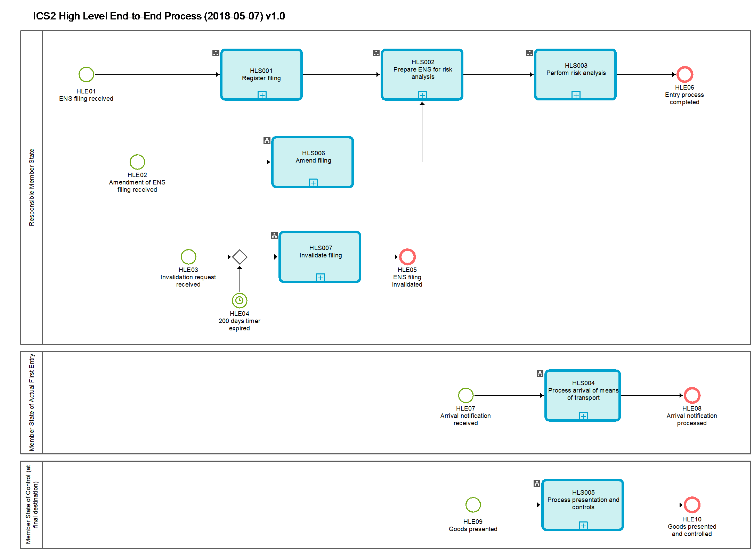
Figure 2: ICS2 High level end-to-end process

Sub-processes

HLS001 - Register filing
Register filing | HLS001
Organisation: National Customs Administration of the Responsible Member State
Input: Received ENS filing
Description:
The ENS filing is validated in an automated process. The validation comprises semantical and syntactical checks in order to ensure workability and data consistency as well as the identification of the kind of filing.
If the ENS filing is not valid:
- it is rejected;
- the person filing is notified of the rejection and of the errors that caused the rejection.
If the ENS filing is valid:
- It is registered; an MRN is generated and allocated to the received filing.
- The person filing is notified of the registration and the MRN which was allocated to the filing.
- When the carrier is different from the person filing and the carrier can be identified from the data derived from the filing, and the carrier has requested to be notified and is connected to the system he will also be notified.
Output (Final situation):
The filing is either rejected or registered.

Business Process Model
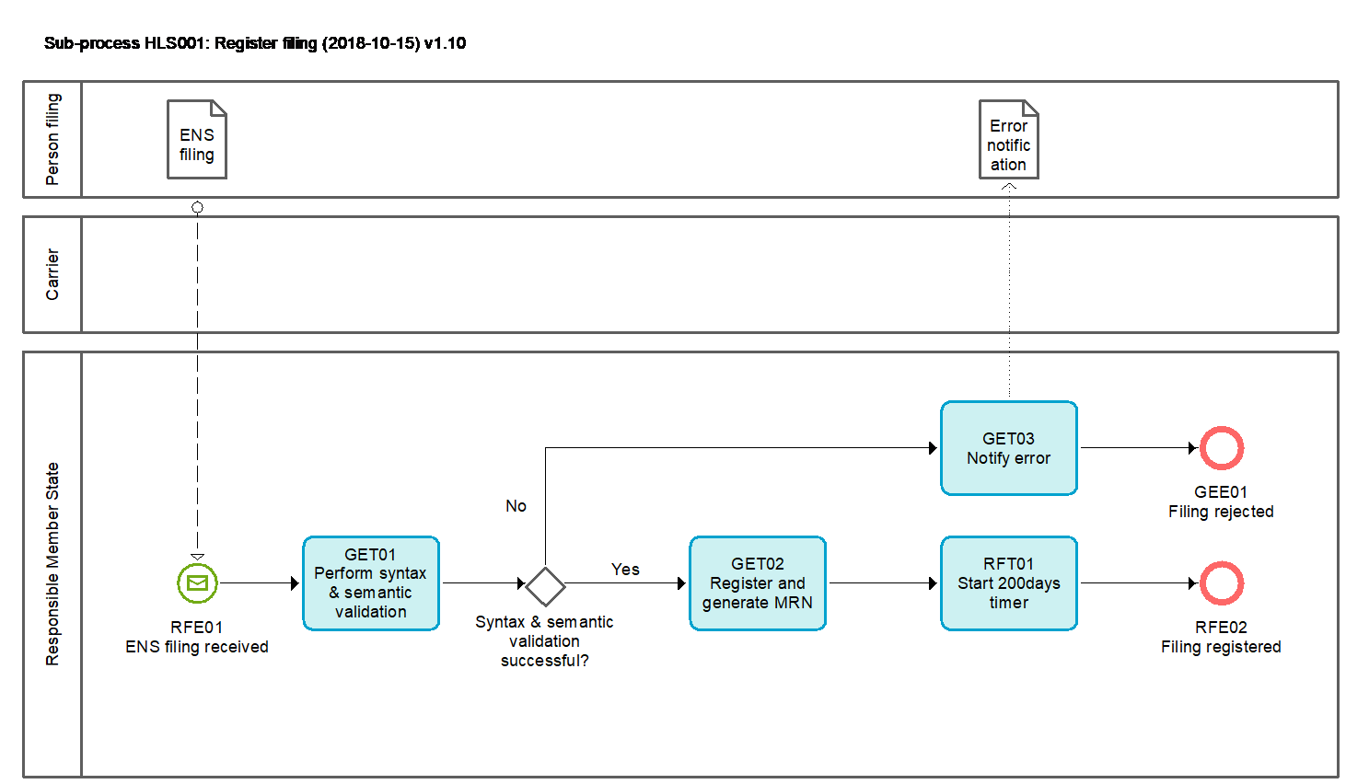
Figure 3: HLS001 Register filing sub-process

Tasks

GET01 - Perform syntax and semantic validation
Perform syntax and semantic validation | GET01
Organisation: National Customs Administration of Responsible Member State or National Customs Administration of Member State of actual first entry
Input: ENS filing, Arrival notification, Amendment of ENS filing, Invalidation request
Description:
The input file is validated in an automated process. The validation comprises validation of message syntax, checks of the compliance with business rules and conditions as well as reference data.
If the input file is not valid it is rejected;
If the input file is valid it is further processed.
Output (Final situation):
The validation will have the following possible outcomes:
- Successful;
- Unsuccessful, in which case
  - the error description will be generated
  - the input file will obtain the state 'rejected'

GET03 - Notify error
Notify error | GET03
Organisation: National Customs Administration of Responsible Member State
Input: Unsuccessful validation results - containing the error description
Description:
The file is not valid and rejected. The person filing is notified of the rejection and of the errors that caused the rejection.
Output (Final situation):
The notification of error is generated and sent to the person filing and the process ends.

GET02 - Register and generate MRN
Register and generate MRN | GET02
Organisation: National Customs Administration of Responsible Member State or National Customs Administration of Member State of actual first entry
Input: Valid ENS filing
Description:
Valid ENS filing is registered; an MRN is generated and allocated to the received ENS filing.
In the case of received filing F25 (reference to the MAWB containing the list of underlying HAWB(s)), no additional MRN will be generated and the already generated MRN(s) for the previously received and related filing(s) F23 will be used.
In the case of ENS filing containing minimum data-set for air cargo pre-loading processes, besides the above conditions that need to be met for notifying the carrier, the air carrier also needs to be identifiable from the data contained in the ENS filing: MAWB reference number.
Output (Final situation):
The ENS filing was registered and MRN has been generated.
The person filing and the carrier (where applicable) has been notified.
The ENS filing obtains the state 'registered'.

RFT01 - Start 200 days timer
Start 200 days timer | RFT01
Organisation: National Customs Administration of Responsible Member State
Input: Registered ENS filing
Description:
The 200 days timer is started for the registered ENS filing. When the goods declared in the ENS filing do not arrive within 200 days the filing will be invalidated (legally not deemed being lodged).
Output (Final situation):
200 days countdown started.

Events

RFE01 - ENS filing received
ENS filing received | RFE01
Organisation: National Customs Administration of Responsible Member State
A person lodges an ENS filing.

GEE01 - Filing rejected
Filing rejected | GEE01
Organisation: National Customs Administration of Responsible Member State
ENS filing is rejected.

RFE02 - Filing registered
Filing registered | RFE02
Organisation: National Customs Administration of a Member State
ENS filing is registered and, where applicable, MRN is generated.

HLS002 – Prepare ENS for risk analysis
Prepare ENS for risk analysis | HLS002
Organisation: National Customs Administration of the Responsible Member State
Input: Registered ENS filing
Description:
This sub-process comprises the following actions on the registered ENS filing:
- Data cleansing and validation in terms of syntax, semantics and the relevant ENS's lifecycle status Management of the timers for the completion of risk analysis
- Enrichment of the PLACI/ENS
- Extraction of the PLACI (i.e. 7+1 data elements), where applicable, and the triggering of the air pre-loading risk analysis
- Linking of the related filings in order to compose a complete ENS
- Triggering of the full risk analysis
Output (Final situation):
The registered ENS filing is either prepared for the air pre-loading risk analysis or the full risk analysis.

Business Process Model
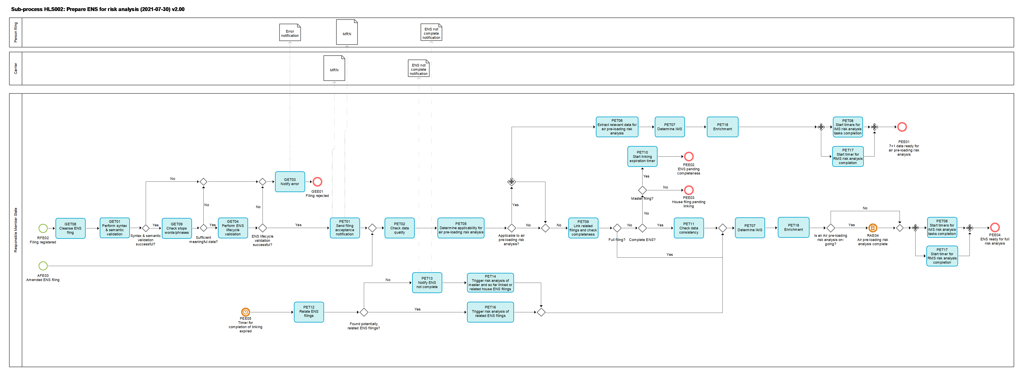
Figure 4: HLS002 Prepare ENS for risk analysis sub-process

Tasks

GET08 – Cleanse ENS filling
Cleanse ENS filling | GET08
Organisation: National Customs Administration of Responsible Member State
Input: ENS filing, Amendment of ENS filing
Description
The cleansing of the ENS data removes symbols and strings from the ENS filing according the common pre-defined rules agreed with the Member states.
The cleansed version of the ENS filing is stored (and the non-cleansed for the purpose of enrichment) and the sub-process continues.
Output (Final situation):
The cleansed version of the ENS filing is stored.

GET01 – Perform syntax and semantic validation
Perform syntax and semantic validation | GET01
Organisation: National Customs Administration of Responsible Member State or National Customs Administration of Member State of actual first entry
Input: ENS filing, Arrival notification, Amendment of ENS filing, Invalidation request
Description:
The input file is validated in an automated process. The validation comprises validation of message syntax, checks of the compliance with business rules and conditions as well as reference data.
If the input file is not valid it is rejected.
If the input file is valid it is further processed.
Output (Final situation):
The validation will have the following possible outcomes:
- Successful;
- Unsuccessful, in which case
  - the error description will be generated
  - the input file will obtain the state 'rejected'

GET09 – Check stop words/phrases
Check stop words/phrases | GET09
Organisation: National Customs Administration of Responsible Member State
Input: ENS filing, Amendment of ENS filing
Description
The input cleansed version of the ENS filing is checked against the pre-defined stop words/phrases per data element. In case the data element contains only stop words/phrases it is considered empty and, if the data element is mandatory, the ENS filing is rejected due to poor data quality.
The stop words/phrases are not removed from the data elements of the ENS filing.
If the validation is successful, the ENS filing the state 'accepted' and the sub-process continues.
If the validation fails the ENS filing obtains the state 'rejected' and the sub-process ends.
Output (Final situation):
The state of the ENS filing will be either changed to 'accepted' or to 'rejected' due to insufficient data quality.

GET04 - Perform ENS-lifecycle validation
Perform ENS lifecycle validation | GET04
Organisation: National Customs Administration of Responsible Member State
Input: ENS filing, Amendment of ENS filing, or Invalidation request
Description
The ENS lifecycle validation checks
- Whether the ENS filing is in the correct state regarding the ENS lifecycle’s sequence of the process (E.g. whether an ENS filing refers to a journey of a means of transport which arrived already in the past, or the goods covered by the ENS filing were already presented to the customs and effectively the ENS cannot be filed for the same goods already presented, or ENS cannot be amended or invalidated) and;
- Whether relevant key data; in particular data elements which are used as a unique linking key are unique. In the case of indicated split shipments (i.e. ENS filing containing defined split shipment code indicator) where unique linking key data can be re-used for the remaining goods after the shipment was split, the ENS filing will be processed.
For an ENS amendment;
- That the state of the original ENS filing is not 'presented' or at a state where, for example amendment of the ENS filing is not possible anymore (i.e. customs decided to perform controls, or trader notified by the customs that goods are to be controlled).
- That no particulars were amended which are not allowed to be amended.
- The person filing the amendment needs to be the declarant or the representative of the ENS filing referred to.
For an invalidation request;
- The related ENS filing is required to be in a state prior to the state 'presented'.
- The person filing the invalidation request needs to be the declarant or the representative of the ENS filing referred to.

If the ENS lifecycle validation is successful, the input file obtains the state 'accepted' and the sub-process continues.
If the ENS lifecycle validation fails the input file obtains the state 'rejected' and the sub-process ends.
Output (Final situation):
The state of the input file will either be changed to 'accepted' or 'rejected'.

GET03 - Notify error
Notify error | GET03
Organisation: National Customs Administration of Responsible Member State or National Customs Administration of Member State of actual first entry
Input: Unsuccessful validation results - containing the error description
Description:
The file is not valid and rejected. The person filing is notified of the rejection and of the errors that caused the rejection.
Output (Final situation):
The notification of error is generated and sent to the person filing and the process ends.

PET01 - Send filing acceptance notification
Send filing acceptance notification | PET01
Organisation: National Customs Administration of Responsible Member State
Input: Successful validation results
Description
The registration of the filing and assigned MRN are notified to the person filing and to the Carrier when it has requested to be notified.
Output (Final situation)
The person filing and where applicable the carrier were notified.

PET02 - Check data quality
Check data quality | PET02
Organisation: National Customs Administration of Responsible Member State
Input: Accepted ENS filing or Amended ENS filing
Description
An automated check regarding data quality will be performed. This is in order to flag an ENS filing which is of inappropriate data quality. This flag will be taken into account in the sub-process described in Section 2.1.3 HLS003 - Perform risk analysis.
Output (Final situation):
Data quality check results, which will either be
- 'ok', or
- 'flagged', in the case check resulted in identified data quality issue within the ENS filing’s data element(s).

PET04 – Manage timer for completion of risk analysis
Manage timer for completion of risk analysis | PET04
Organisation: National Customs Administration of Responsible Member State
Input: Accepted ENS filing or Amended ENS filing
Description:
It is determined whether a timer for the completion of full security and safety risk analysis is applicable to the ENS filing and when applicable the appropriate timer is selected and started.
No timer is to be applied for ENS filings F14, F15, F16, F22, F23, F24, F25, F26, F32, F33, F43, F44, F53, F54 and F55. In the case of filings F23, F24, F25, F32 and F43 the timer is not applied due to the legal requirement to complete the risk analysis immediately. However, if the risk is identified or additional risk analysis needs to be carried out, the ‘time-limit’ for the completion of the risk analysis is suspended.
For ENS filings F10, F11, F12, F13 and F45 the timer is set to 24h upon reception of the ENS filing in cases of Article 105 (a) UCC-DA.
For ENS filings F10, F11, F12, F13 and F45 the timer is set to 4h upon reception of the ENS filing in cases of Article 105 (b) UCC-DA.
For ENS filings F10, F11, F12, F13 and F45 the timer is set to 2h upon reception of the ENS filing in cases of Article 105 (c) and (d) UCC-DA and cases of Article 109 UCC-DA.
For ENS filings F20, F21, F27, F28, F29, F30, F31, F42 the timer is set to 4h upon reception of the ENS filing in cases of Article 106 (2) (b) UCC-DA.
For ENS filings F20, F21, F27, F28, F29, F30, F31, F42 the timer is set to the remaining time until the expected (scheduled) time of arrival of the aircraft upon reception of the ENS filing in cases of Article 106 (2) (a) UCC-DA.
For ENS filing F41, F51 and F52 the timer is set to 1h upon reception of the ENS filing in cases of Article 107 (a) UCC-DA.
For ENS filing F41, F51 and F52 the timer is set to 2h upon reception of the ENS filing in cases of Article 107 (b) UCC-DA.
For ENS filing F34, F40 and F50 the timer is set to 1h upon reception of the ENS filing.
In case of Amended ENS filing, the timer for the original ENS filing will be stopped and no timer for the amended ENS filing will be started.
Output (Final situation):
The timer can either be started, stopped or not applicable.

PET05 – Determine applicability for air pre-loading risk analysis
Determine applicability for air pre-loading risk analysis | PET05
Organisation: National Customs Administration of a Responsible Member State
Input: Accepted ENS filing or Amended ENS filing
Description:
It is determined whether the ENS filing is subject to air pre-loading risk analysis.
Only the following ENS filings are subject to air pre-loading risk analysis: F20, F23, F24, F26, F28, F32 and F43.
Output (Final situation):
It is determined whether the ENS filing is subject to air pre-loading risk analysis.

PET06 – Extract relevant data for air pre-loading risk analysis
Extract relevant data for air pre-loading risk analysis | PET06
Organisation: National Customs Administration of a Responsible Member State
Input: Accepted ENS filing or Amended ENS filing
Description:
In the case a full ENS is filed at pre-loading phase (e.g. filing F20), only 7+1 data which are required by air pre-loading risk analysis are extracted from the filing.
Output (Final situation):
Relevant extracted datasets for air pre-loading risk analysis are composed.

PET07 – Determine IMS
Determine IMS | PET07
Organisation: National Customs Administration of a Responsible Member State
Input: 7+1 data elements or ENS
Description:
For air pre-loading risk analysis involved Member States are identified using one of the following methods:
- all Member States are considered to be Involved Member States, with the exception of the RMS;
- IMSs are identified through a set of relevant data elements contained in the ENS filing(s).
For the full risk analysis, the Involved Member States are identified through a set of relevant data elements contained in the ENS filing(s). Below are business rules i.e. data elements that should be considered per mode of transport and/or business model to identify an IMS:

Sea and inland waterways (maritime cargo):
• Consignee country code master bill of lading level
• Consignee country code house bill of lading level
• Consignor country code house bill of lading, if country code equals the code of the ICS2 MS
• Carrier country code
• Buyer country code
• Seller country code, if the case country code equals the code of the ICS2 MS
• Notify party country code master bill of lading level
• Notify party country code house bill of lading level
• Additional supply chain actor(s) identification
• Place of delivery code master bill of lading level
• Place of delivery code house bill of lading level
• Countries of routing of means of transport
• Countries of routing of the consignment codes
• Place of unloading

General air cargo:
• Consignee country code master air waybill level
• Consignee country code house air waybill level
• Consignor country code house air waybill, if country code equals the code of the ICS2 MS
• Carrier country code
• Notify party country code master air waybill level
• Notify party country code house air waybill level
• Additional supply chain actor(s) identification
• Place of delivery code master air waybill level
• Place of delivery code house air waybill level
• Countries of routing of means of transport
• Countries of routing of the consignment codes
• Place of unloading

Express consignments:
• Consignee country code master air waybill level
• Consignee country code house air waybill level
• Consignor country code house air waybill, if country code equals the code of the ICS2 MS
• Carrier country code
• Additional supply chain actor(s) identification
• Countries of routing of means of transport
• Countries of routing of the consignment codes
• Place of unloading

Postal consignments:
• Consignee country code master air waybill level
• Consignee country code house air waybill level
• Carrier country code
• Additional supply chain actor(s) identification
• Countries of routing of means of transport
• Place of unloading

Road and Rail traffic:
• Consignee country code master bill of lading level
• Consignee country code house bill of lading level
• Consignor country code house bill of lading, if country code equals the code of the ICS2 MS
• Carrier country code
• Buyer country code
• Seller country code, if the case country code equals the code of the ICS2 MS
• Countries of routing of means of transport
• Place of unloading
• Nationality of active means of transport crossing the border and its Identity
• Nationality of passive means of transport crossing the border and its Identity]
Output (Final situation):
The Member States to be involved in an air pre-loading risk analysis or full risk analysis are determined.

PET08 – Start timers for IMS risk analysis tasks completion
Start timers for IMS risk analysis tasks completion | PET08
Organisation: National Customs Administration of Responsible Member State
Input: PLACI - 7+1 data elements or ENS
Description:
The appropriate timers' values for the completion of e-Screening on 7+1 data elements or on an ENS are calculated and started. Each IMS will have its own individual timer which indicates the time remaining to provide feedback to the RMS. The timer values need to be agreed as per scenario with regard to the overall timer for the RMS to complete the risk analysis.
Output (Final situation):
The timer values for all IMS are known and countdowns are activated.

PET09 – Link related filings and check completeness
Link related filings and check completeness | PET09
Organisation: National Customs Administration of Responsible Member State
Input: Accepted ENS filing or Amended ENS filing
Description:
In case of
- the filings F10, F11, F20, F27, F28, F29, F30, F31, F34, F50 and F51, the ENS will obtain the state 'ENS complete';
- the filings F12, F13, F21, F40, F41, F42, F45, F52 will obtain the state 'ENS complete' if all related house level filings have been lodged or the state 'ENS pending completeness' if any of the related house level filings are missing;
- the filings F14, F15, F16, F22, F23, F24, F26, F32, F33, F43, F44, F53, F54, F55 will obtain the state 'Linked' if they have been linked to the related master level filing that has been also lodged or the state 'Pending linking' if the related master level filing is missing.
By using the unique linking key (ULK) defined for the given scenario it will be determined whether related ENS filings at master and house level already exist. It will be furthermore checked whether the ENS is already complete after related master and house level ENS filings were found.
The linking of the filings should be done as per following possible combinations:
- Air (general cargo):
  - Partial filing(s) F23 are to be linked with the subsequent partial filing F25 (filing F25 triggers the linking process with the filing(s) F23). The linking of those two filings can be either done by referring in the F25 filing to the HAWB(s) which was/were declared in the F23 filing(s) or to the MRN(s) which were assigned to the F23 filing(s).
  - Partial filing(s) F22 and F33 are to be linked with the partial filing F21 both lodged pre-arrival (filing F21 triggers process of linking with the filing(s) F22 and F33). Three ENS data elements are to be used to form the unique linking key between two or more partial ENS filings submitted by different economic operators (i.e. carrier and freight forwarder submissions), notably the MAWB and HAWB, declarant EORI number and the EORI number of the supplementary declarant. The filings F21, F22 and F33 can be linked via the MAWB number and HAWB number(s) which will be the same in both filings and the EORI number of the supplementary declarant in filing F21 which corresponds to the declarant EORI numbers in filing(s) F22 and F33; or
  - Partial filing(s) F26 (lodged pre-loading) are to be linked with the partial filing F21 (lodged pre-arrival) (filing F21 triggers the process of linking with the filing(s) F26). The unique linking key will be identical as mentioned above.
The ENS for air cargo general is considered to be complete when all supplementary declarants of the partial ENS filings (which relate to the same MAWB) have filed partial ENS and their filings were successfully linked with the related MAWB filing.

- Postal consignments:
  - Partial filing(s) F43 are to be linked with the subsequent partial filing F44 (filing F44 triggers the process of linking with the filing(s) F43). The filing F44 will refer to the postal item number used in filing F43 and relate the item to a given unique receptacle.
  - Partial filing(s) F43/F44 (already filed and linked at pre-loading) to be linked with the partial filing F40, F41, F42, F45 (lodged-pre-arrival) (filing F40, F41, F42, F45 triggers the process of linking with the filing(s) F43/F44 (two of them linked at pre-loading)). The filing F40, F41, F42, F45 will be linked with the F43/44 data via the receptacle numbers which are declared in F40, F41, F42 and F45, and F44 (latter one already linked to F43).
The ENS for postal consignments on the different modes of transport is considered to be complete when all receptacles declared in the respective filing – F40, F41, F42 or F45 – are linked to F44 filings which were all successfully linked to F43 filings (item data) at an earlier stage.

- Sea and inland waterways (maritime cargo):
  - Partial filing F13 to be linked with the partial filing(s) F16 (filing F13 triggers the process of linking with the filing(s) F16); or
  - Partial filing F12 to be linked with the partial filing(s) F15 (filing F12 trigger the process of linking with the filing(s) F15); or
  - Partial filing F12 to be linked with the partial filing(s) F14 and partial filing(s) F16 (filing F12 triggers the process of linking with the filing(s) F14);
  - Partial filing F12 to be linked with the partial filing(s) F14 and F16 and partial filing(s) F15.
Four ENS data elements are to be used to form the linking key between two or more partial ENS filings submitted by economic operators (i.e. carrier, freight NVOCC (i.e. freight forwarder and consignee submissions), notably the MBoL, declarant EORI number, carrier identification number and EORI number of the supplementary declarant.
The filing F13 is linked to the partial filing(s) F16 by matching of the same straight bill of lading number in F13 and F16. Moreover, the declarant EORI number of filing F13 has to correspond to the carrier's identification number provided in the filing(s) F16 and the declarant identification number of filing F16 has to correspond to identification number of the supplementary declarant in filing F13.
The unique linking key to link a filing F12 to filings F14 and F15 is the same as the one mentioned above. Lower house level filings are matched to upper house level filings by the identification number of the supplementary declarant of the upper house level filing which has to correspond to the identification number of the declarant in the lower house level filing and the identification number of the carrier provided corresponds in both filings.
The composed ENS is considered to be complete when all supplementary declarants of partial ENS filings (which relate to the same MBoL) have filed partial ENS and they were successfully linked with the MBoL level filing (F12 or F13).

- Air (express cargo):
  - Partial filing(s) F33 are to be linked with the partial filing F21 both lodged pre-arrival (filing F21 triggers process of linking with the filing(s) F33). Three ENS data elements are to be used to form the unique linking key between two or more partial ENS filings submitted by different economic operators (i.e. carrier and freight forwarder submissions), notably the MAWB and HAWB, declarant EORI number and the EORI number of the supplementary declarant. The filings F21 and F33 can be linked via the MAWB number and HAWB number(s) which will be the same in both filings and the EORI number of the supplementary declarant in filing F21 which corresponds to the EORI number of the declarant in filing(s) F33; or
  - Partial filing(s) F32 (lodged pre-loading) are to be linked with the partial filing F21 (lodged pre-arrival) (filing F21 triggers the process of linking with the filing(s) F32). The unique linking key will be identical as mentioned above.
The ENS for air cargo express is considered to be complete when all supplementary declarants of partial ENS filings (which relate to the same MAWB) have filed partial ENS and their filings were successfully linked with the related MAWB filing.
- Rail:
  - Partial filing F52 to be linked with the partial filing(s) F53 (filing F52 trigger the process of linking with the filing(s) F53); or
  - Partial filing F52 to be linked with the partial filing(s) F54 and partial filing(s) F55 (filing F52 triggers the process of linking with the filing(s) F54);
Four ENS data elements are used to form the unique linking key between the house consignments and the ENS in case of partial ENS filings submitted by the economic operators (i.e. carrier, house filer (i.e. freight forwarder, consolidator and consignee submissions), notably the MBoL, declarant EORI number, carrier identification number and EORI number of the supplementary declarant.
The unique linking key used for linking the house consignments from F53 or F54 to the ENS based on F52 is the same as the one mentioned above. Lower house level filings are matched to upper house level filings by the identification number of the supplementary declarant of the upper house level filing which has to correspond to the identification number of the declarant in the lower house level filing and the identification number of the carrier provided corresponds in both filings.
The goods shipment information provided via F55 is linked to the corresponding house consignment in F54 based on the MBoL, carrier identification number, house transport document reference and the identification number of the declarant of F55.
The ENS is considered to be complete when all supplementary declarants of the partial ENS filings (which relate to the same MBoL) have filed their partial ENS data and they were successfully linked with the MBoL level filing F52.
Output (Final situation):
- the filings F10, F11, F20, F27, F28, F29, F30, F31, F34, F50 and F51, the ENS will obtain the state 'ENS complete';
- the filings F12, F13, F21, F40, F41, F42, F45, F52 will obtain the state 'ENS complete' if all related house level filings have been lodged or the state 'ENS pending completeness' if any of the related house level filings are missing;
- the filings F14, F15, F16, F22, F23, F24, F26, F32, F33, F43, F44, F53, F54, F55 will obtain the state 'Linked' if the related master level filing has been lodged or the state 'Pending linking' if the related master level filing is missing.

PET10 –Start linking expiration timer
Start linking expiration timer | PET10
Organisation: National Customs Administration of Responsible Member State
Input: ENS in the state 'ENS pending completeness'
Description
A partial master filing triggers the start of the timer for linking it with the related house level filings. The time allocated for the linking of partial filings should allow sufficient time for the completion of the risk analysis according to the legally set deadlines. Those deadlines depend on the given ENS scenario (i.e. transport mode and situations that determine time-limits – see Articles 105, 106, 107 UCC-DA).
Output (Final situation):
The timer for completing the ENS by linking house level filings with a partial master level filing is started.

PET11 - Check data consistency
Check data consistency | PET11
Organisation: National Customs Administration of Responsible Member State
Input: Complete ENS
Description
Data consistency of linked partial ENS filings will be checked. This is done in order to ensure the appropriate ENS data consistency is provided for the risk analysis. The consistency check will take into account inconsistencies such as major weight and piece count discrepancies, changed actors, discrepancies in the referenced transport documents at the level of master and underlying house filings as well as differences in air pre-loading and pre-arrival filings (algorithms and reference data for this task to be defined).
Output (Final situation):
Data consistency check results, which will either be
- 'ok', or
- 'flagged', in the case the result is identified inconsistency.

PET12 – Relate ENS filings
Relate ENS filings | PET12
Organisation: National Customs Administration of Responsible Member State
Input: ENS in the state 'ENS pending completeness' for which the linking expiration timer has expired
Description
This automated task tries to relate ENS filings by taking into account other data elements with common attributes in terms of their content (e.g. container numbers, shipping marks etc.) in addition to the ULK used for task PET09 – Link related filings and check completeness. In case the house level partial ENS filings which are potentially to be related to a given partial master level filing are found, those filings will be proposed for the final manual determination and linking.
Output (Final situation):
Related ENS filings found or not found.

PET13 - Notify ENS not complete
Notify ENS not complete | PET13
Organisation: National Customs Administration of Responsible Member State
Input: ENS in the state 'ENS pending completeness'
Description
The person filing and the carrier when different from the person filing and has requested to be informed and is connected to the customs system will be informed that the ENS is not complete. The notification will include the relevant information i.e. which ENS filings from which person expected to file are still missing.
Output (Final situation):
The person filing and where applicable the carrier are informed about the fact that no complete ENS was lodged so far.

PET14 – Trigger risk analysis of master and so far linked or related house ENS filings
Trigger risk analysis of master and so far linked or related house ENS filings | PET14
Organisation: National Customs Administration of Responsible Member State
Input: ENS in the state 'ENS pending completeness'
Description
In order to perform a risk analysis for all goods carried on the means of transport and on the data received so far and after the expiration of the linking timer (which equals expiration of the minimum time necessary to complete risk analysis per applicable filing scenario – see Articles 105, 106 107 UCC-DA) the risk analysis of the master level ENS filing and so far linked or related house ENS filings is manually triggered.
Output (Final situation):
The incomplete ENS is considered to be ready for risk analysis. It will obtain the state 'considered complete for RA'.

PET16 – Trigger risk analysis of related ENS filings
Trigger risk analysis of related ENS filings | PET16
Organisation: National Customs Administration of Responsible Member State
Input: Related ENS filings which are manually linked
Description
The related ENS filings are triggered to risk analysis.
Output (Final situation):
Risk analysis for the related ENS was triggered.

PET17 – Start timer for RMS risk analysis completion
Start timers for IMS risk analysis tasks completion | PET17
Organisation: National Customs Administration of Responsible Member State
Input: PLACI - 7+1 data elements or ENS
Description:
The appropriate timer value for the completion of e-risk analysis on 7+1 data elements or on an ENS is calculated and started. The timer values need to be agreed as per scenario.
Output (Final situation):
The timer value for the RMS is known and countdown is started.

PET18 – Enrichment
Enrichment | PET18
Organisation: National Customs Administration of Responsible Member State
Input: PLACI 7+1 data elements or ENS
Description:
A PLACI or an ENS is enriched.
Output (Final situation):
Enriched ENS/PLACI.

Events

RFE02 - Filing registered
Filing registered | RFE02
Organisation: National Customs Administration of a Member State
A registered ENS filing is available for preparation for risk analysis.

GEE01 - Filing rejected
Filing rejected | GEE01
Organisation: National Customs Administration of Responsible Member State
The ENS filing is rejected. The sub-process ends.

AFE03 – Filing amended
Filing amended | AFE03
Organisation: National Customs Administration of Responsible Member State
An amended ENS filing is available for preparation for risk analysis.

PEE01 – 7+1 data is ready for air pre-loading risk analysis
7+1 data is ready for air pre-loading risk analysis | PEE01
Organisation: National Customs Administration of Responsible Member State
PLACI (7+1) data is ready for air pre-loading risk analysis.

PEE02 – ENS pending completeness
ENS pending completeness | PEE02
Organisation: National Customs Administration of Responsible Member State
ENS is not yet complete.

PEE03 – House filing pending linking
House filing pending linking | PEE03
Organisation: National Customs Administration of Responsible Member State
A partial house level ENS filing is not yet linked to a master level ENS filing.

PEE04 - Ready for full risk analysis
ENS ready for full risk analysis | PEE04
Organisation: National Customs Administration of Responsible Member State
An ENS will be considered ready for full risk analysis as soon as one of the following occurs:
- A full ENS filing is registered;
- All partial ENS filings are successfully linked;
- All partial ENS filings are manually related;
- The risk analysis process will be manually triggered to run on the master level filing only, or on the enhanced master level filing, which has been partially related to house level filings (but some are missing).
ENS obtains the state 'ready for full risk analysis'.
The sub-process ends.

PEE05 – Timer for completion of linking expired
Timer for completion of linking expired | PEE05
Organisation: National Customs Administration of Responsible Member State
The timer for linking a partial master level ENS filing has expired. This triggers task PET12.

HLS003 - Perform risk analysis
Perform risk analysis | HLS003
Organisation: National Customs Administration of the Responsible Member State
Location : Addressed office of the Responsible Member State
Input: Registered ENS filing which is prepared for risk analysis
Description:
Risk analysis process is triggered at the moment when the ENS status is complete (i.e. successful linking process of partial ENS filings or complete ENS filing) or in the case of a full ENS or, in the case of air cargo pre-loading at receipt of the required minimum 7+1 data. The risk analysis for the maritime deep-sea containerised traffic (Art 105 (a) DA) is triggered upon receipt of the full ENS filing, or in the case of application of Art 127 (6) UCC (i.e. multiple filing) upon receipt of the carrier's ENS filing. As per legal provisions, risk analysis needs to be completed within 24 hours of the said filings.
The Member States to be involved are identified and the registered filing is made available to all the relevant Member States for e-screening performance (i.e. those identified in the ENS data-set that are in the supply chain of the given consignment(s) for full security and safety risk analysis).
Simultaneously, the e-screening is also performed by the Responsible Member State, as part of its overall electronic risk analysis process. Results of the e-screening from involved Member States are collected, allocated and made available to the Responsible Member State before that Member State completes the risk analysis process. Depending on the results of overall risk analysis the following action is to be taken:
- When no hit was indicated by automated risk analysis of the Responsible Member State, and there is no hit or confirmed hit from the involved Member State(s), and there is no data quality or data inconsistency flag, there is nothing further to do.
- When a hit was indicated by automated risk analysis, or a data quality or data inconsistency was flagged (or confirmed hit received as a result of e-screening done by involved Member State(s)), it is followed by the manual review / risk mitigation of the validity of the machine-identified hit or flag by a risk analysis official of the Responsible Member State. In the case of air (general cargo, postal consignments, express consignments) when at the phase of pre-loading risk analysis the outcome resulted in confirmation of other type of security and safety risk (not air cargo security), this result is taken into account in the further process of risk analysis):
  - The hit of automated risk analysis is identified after the manual review as not valid i.e. ‘false positive hit’. The hit is downgraded to no hit, recorded as ‘false positive’ and no measures to be taken,
  - The hit of the automated risk analysis or the flag produced due to the data quality or data inconsistency issue, prompts the risk analysis official of Responsible Member State to receive improved data quality or to gather further additional information in order to decide on further risk mitigation measure to be taken (this includes also potential results and request made by the involved Member State(s)’ e-screening). Responsible Member State requests for more information from the person filing and informing the carrier when the carrier is different from the person filing about this request, and the carrier can be identified from the data derived from the filing and the carrier has requested to be notified and is connected to the system (Request for Information (RfI) referral to be sent).
    - Person filing (partial) ENS makes available necessary additional information, either through amendment of the original filing (i.e. in the case of data quality/inconsistency issue), or via structured communication as a reply to the request of customs (following the hit of the electronic risk analysis system which prompted such request), or making data available through the access by risk analysis official to the filing person’s proprietary system
    - If the additional information is provided through the amendment of the original (partial) ENS filing, the automated risk analysis process is re-initiated after the amendment is registered
    - If the additional information is provided through the structured communication or via access to the proprietary system of the filing person, the risk analysis official performs additional review based on the information received in order to decide on the presence or absence of the risk.
    - Risk analysis official of the Responsible Member State may need in some circumstances to request for more risk mitigation information also involved Member State(s). Once the request is made, the official(s) of the involved Member State(s) should provide back the necessary requested information with the minimum delay (varying and depending on the available time-limits to perform/conclude risk analysis) to allow responsible Member state to carry out necessary review / risk mitigation and decision making process as part of the overall risk analysis
    - the result of this additional review may be that the security and safety risk is not confirmed, in that case the result is recorded and the process ends, or
    - the risk is confirmed and further risk mitigation measure is necessary. In this case risk analysis official decides for risk mitigation measure as per point 3. below
- Following the process in the point 2. above, or independently, the hit of the automated risk analysis indicates suspicion of presence of a security and safety risk (or air cargo specific security risk in the case of air cargo pre-loading risk analysis), the Responsible Member State risk analysis official confirms the level of risk and decides on the risk mitigation action to be taken (this includes also potential result from e-screening performed by the involved Member State that give rise to this level of suspicion):
  - Risk identified is of a serious security and safety threat that requires immediate action to prohibit loading of goods onto the aircraft or vessel. This scenario is only applicable for the air cargo and for the specific cases of maritime containerised cargo (Article 105 (a) of the Commission Delegated Regulation (EU) 2015/2446). A notification for ‘Do Not Load’ (DNL) (i.e. ‘order’ to prevent goods to be loaded onto the aircraft or vessel) is communicated to the person filing and to the carrier when the carrier is different from the person filing, and the carrier is connected to the system.
  - Risk identified poses a threat of such a nature that it requires immediate intervention at the Office of First Entry according to Art. 186 (6) of the Commission Implementing Regulation (EU) 2015/2447. A decision is taken to perform necessary controls at the office of first entry (this implies also goods that would normally remain on board of the means of transport at their arrival to the customs office of first entry)
  - Risk identified does not pose such a serious threat to the security and safety to warrant an immediate control action at the customs office of first entry. A decision is taken to pass the results of risk analysis and information about the most appropriate place where a control action should be carried out to the relevant Member States, as laid down in Art. 186 (7) of Regulation (EU) 2015/2447 (i.e. customs offices potentially concerned by the movement of the goods, e.g. subsequent customs office(s) of entry (where the goods are unloaded first), customs office(s) responsible for control at the place where goods are presented subsequent to the place of first unloading (e.g. destination feeder seaport) or of final destination indicated in the ENS data-set)

It should be noted that the measures mentioned above are not necessarily to be taken alternatively and can also be applied cumulatively when the risk could not be mitigated by a previously taken measure, e.g. when the additional information requested is not considered to be sufficient to mitigate the suspicion a DNL decision can be the ultimate measure.
A risk analysis result code is to be assigned which depends on the identified level of threat which will influence the decision on whether the goods will be subject to controls and where the controls will take place (COFE or at a later stage like subsequent customs office of entry (first unloading location) or place where goods are presented subsequent to the place of first unloading, or customs office of destination).
In the case of DNL decision, the Responsible Member State informs all Member States about the case applying Article 46 UCC channels. Responsible Member State and involved Member States will adjust and apply within the minimum delay common risk criteria in order to identify high risk consignments with similar characteristics.
Output (Final situation):
Risk analysis was performed and measures to be taken were decided and executed.

Business Process Model
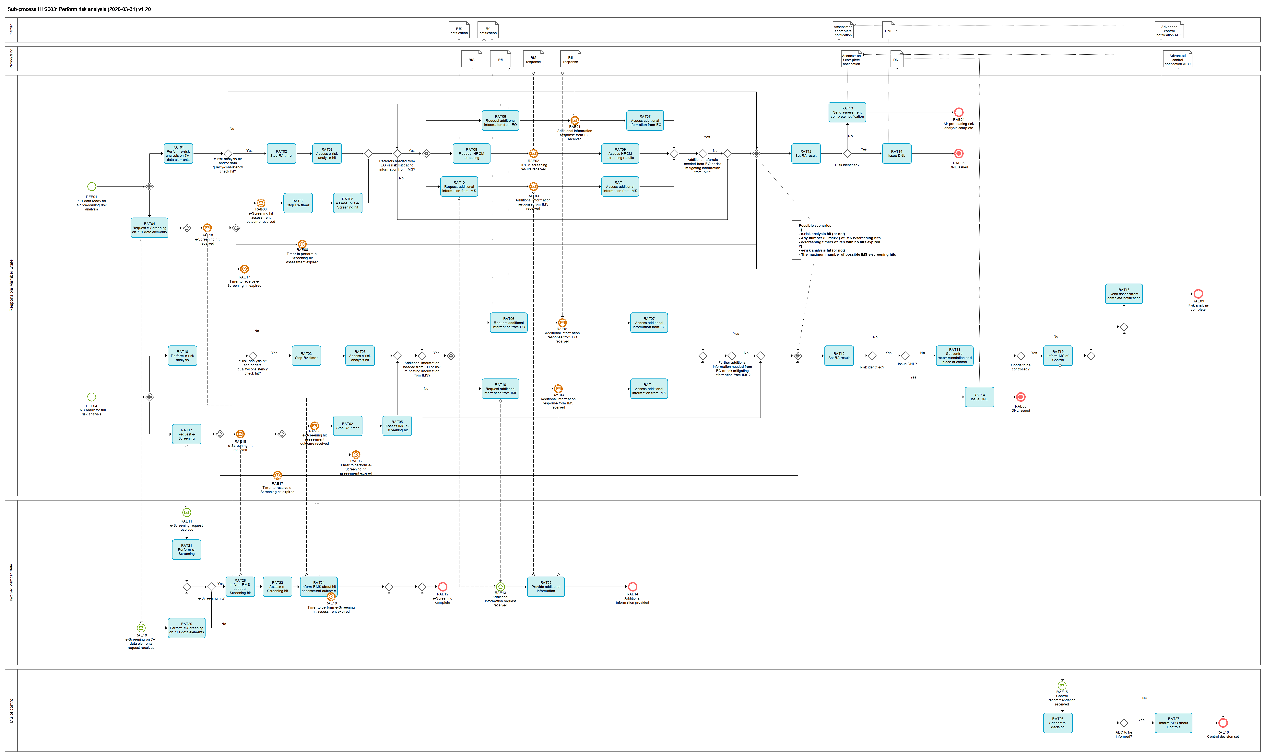
Figure 5: HLS003 Perform risk analysis sub-process

Tasks

RAT01 - Perform e-risk analysis on 7+1 data elements
Perform e-risk analysis on 7+1 data elements | RAT01
Organisation: National Customs Administration of Responsible Member State
Input: PLACI (7+1) data elements
Description:
Received PLACI (7+1) data elements are electronically analysed against air cargo security specific CRC category 1, CRC category 2 and any potential additional national risk profiles not falling in the scope of the CRCs.
Electronic risk analysis (e-risk analysis) either results in an automated ‘match / hit’ of a given CRC / national risk profile or not. Additionally, in case there was a flag from the task PET02 - Check data quality, this information will be brought into the attention of the risk analyst.
Output (Final situation):
This can either result in
- no hit,
- e-risk analysis hit, and/or
- data quality flag

RAT02 - Stop risk analysis timer
Stop risk analysis timer | RAT02
Organisation: National Customs Administration of Responsible Member State
Input:
It could be any one of the below or a combination of them:
- e-risk analysis hit
- data quality flag
- data consistency flag
- e-screening hit assessment
Description:
The time-limits for completion of the risk analysis for the ENS concerned are suspended at the RMS, since either risk is identified, or additional risk analysis needs to be carried out (i.e. review of the e-RA results, data quality issue or data inconsistency, by the risk analysis official – human review and risk mitigation).
(Article 186 (1) of Regulation (EU) 2015/2447)

Output (Final situation):
Timer is stopped.

RAT03 - Assess e-risk analysis hit
Assess e-risk analysis hit | RAT03
Organisation: National Customs Administration of Responsible Member State
Input: Electronic risk analysis (e-risk analysis) result and / or automated result of a data quality and/or consistency issue
Description:
Result of the electronic risk analysis (i.e. match/hit of CRCs / potential national profiles) and/or data quality and/or data inconsistency is presented to the risk analyst.
Customs risk analyst performs additional analysis / review of the electronic risk analysis results, and / or data quality issue, and/or - in the case of full risk analysis only -data inconsistency and decides on risk mitigation measures.
Note: customs risk analyst of the RMS decides on further risk mitigation measures, after it receives results of e-screening from the IMS (i.e. see RAT05 – assess IMS e-screening hit)
Output (Final situation):
Based on the human based additional risk analysis (risk assessment), which takes account also of any potential hit of e-screening by the IMS (RAT05) a decision of the risk analyst can be either:
- Request for additional information (RfI) from the economic operator concerned, and/or
- Request for HRCM-screening (RfS) (air pre-loading only), and/or
- Request for further information from the Involved Member State(s) that may hold necessary additional risk mitigation information, or
- Decision to finalise the risk analysis (i.e. confirm risk or decide that no further action is required at this point in time and register the result).

RAT04 - Request e-Screening on 7+1 data elements
Request e-Screening on 7+1 data elements | RAT04
Organisation: National Customs Administration of Responsible Member State
Input: PLACI (7+1) data elements
Description:
A request for e-Screening is communicated to the Involved Member State(s).
Output: Request was sent to the Involved Member States.

RAT05 - Assess IMS e-Screening hit
Assess IMS e-Screening hit | RAT05
Organisation: National Customs Administration of Responsible Member State
Input: Confirmed e-Screening result communicated by the Involved Member State
Description:
Result of the confirmed e-screening process completed and communicated by the Involved Member State.
Customs risk analyst of the RMS finalises risk assessment.
Output (Final situation):
A decision of the risk analyst can be either:
- Request for additional information (RfI) from the economic operator concerned, and/or
- Request for HRCM-screening (RfS) (air pre-loading only), and/or
- Request for further information from the Involved Member State(s) that may hold necessary additional risk mitigation information, or
- Decision to finalise the risk analysis (i.e. confirm risk or decide that no further action is required at this point in time and register the result).

RAT06 - Request additional information from EO
Request additional information from EO | RAT06
Organisation: National Customs Administration of Responsible Member State
Input: Request for additional information (RfI) from the economic operator concerned
Description:
The RfI in the context of air cargo pre-loading risk analysis process can either concern:
- the need for additional information / documents to be sent by the person filing (i.e. person to which the request is sent)
- the need to improve the data quality of specific date element(s) through amendments of ENS filing, or
- the type of screening (if any) that has already been performed on the consignment.

The RfI in the context of full risk analysis process can either concern:
- the need for additional information/ documents to be sent by the person filing (i.e. person to which the request is sent), or
- the need to improve the data quality of specific date element(s) through amendments of ENS filing.
In the case the customs risk analyst decided that the RfI is necessary, the request is communicated to the economic operator concerned.
The request is sent to the person filing and to the carrier when the carrier is known, connected to the system and has requested to be informed.
Output (Final situation):
It can either be
- request for additional information, or
- request to amend an ENS filing

RAT07 - Assess additional information from EO
Assess additional information from EO | RAT07
Organisation: National Customs Administration of Responsible Member State
Input: Additional information received from the EO
Description:
The customs risk analyst performs additional assessment based on the information received from the EO.
In the case of air pre-loading risk analysis, the outcome of the assessment can be the necessity for a HRCM screening to be performed.
Output (Final situation):
It can either be additional referrals are needed, or not.

RAT08 - Request HRCM screening
Request HRCM screening | RAT08
Organisation: National Customs Administration of Responsible Member State
Input: Request for HRCM-screening (RfS)
Description:
In the case the customs risk analyst decided that HRCM screening is necessary, the request is communicated to the person filing and to the carrier, provided the carrier is known, connected to the system and has requested to be informed.
HRCM screening can be also requested in a combination with, or after the request for additional information to the EO or IMS were communicated and the assessment of additional information leads to the need for the HRCM (escalation measure). Request for HRCM screening may also be triggered while the RfI request is still in pending status, and the customs analyst decides nevertheless to escalate the risk mitigation measure by requesting HRCM screening (this is in particular valid in the case when the EO does not provide necessary additional information or improve data quality via the amendment of the ENS filing, in a 'reasonable time-frame').
Output (final situation): The request for HRCM screening is communicated to the person filing and where applicable to the carrier.

RAT09 - Assess HRCM screening results
Assess HRCM screening results | RAT09
Organisation: National Customs Administration of Responsible Member State
Input: HRCM screening results
Description
The customs risk analyst assesses the available results of the HRCM screening.
Output (Final situation):
HRCM screening results have been assessed.

RAT10 - Request additional information from IMS
Request additional information from IMS | RAT10
Organisation: National Customs Administration of Responsible Member State
Input: Request for further information from the Involved Member State(s)
Description:
In the case the customs risk analyst decided that additional risk mitigation information is necessary to be obtained from a specific Involved Member State, the request is communicated to that Member State.
Output (Final situation):
Additional risk mitigation information request communicated to the specific Involved Member State.

RAT11 - Assess additional information from IMS
Assess additional information from IMS | RAT11
Organisation: National Customs Administration of Responsible Member State
Input: Additional information received from the IMS
Description:
The customs risk analyst assesses the additional information received from the IMS.
Output (Final situation):
Customs risk analysts completes the assessment.

RAT12 - Set RA result
Set RA result | RAT12
Organisation: National Customs Administration of Responsible Member State
Input: will either be
- no hit from e-risk analysis and e-screening, or
- any hit, along with the results of the assessment of the risk analyst
Description:
In case of no hit, the risk analysis result will be automatically set to 'No risk'.
Result of the confirmed e-risk analysis (through manual risk assessment, and supported where necessary by additional information provided by the EO and/or involved Member State) and / or of the confirmed e-screening process completed and communicated by the Involved Member State is transformed into the final risk analysis result by the risk analyst.
The risk result can be:
- No risk
- Risk identified
- Risk identified - DNL (where applicable)
Output (Final situation):
The risk result can be:
- No risk, ENS will obtain the state: 'Full RA complete - For now no further action necessary '
- Risk identified, ENS will obtain the state: 'Full RA complete - Risk identified'
- Risk identified - DNL (where applicable), ENS will obtain the state: 'Full RA complete - DNL'

RAT13 - Send assessment complete notification
Send assessment complete notification | RAT13
Organisation: National Customs Administration of Responsible Member State
Input: Risk analysis result
Description
In case the risk analysis result was other than 'Risk identified - DNL', the person filing will be notified about the completion of the risk analysis.
Where the carrier is known, different from the person filing, connected to the system and has requested to be informed he will be also informed in parallel.
Output: The person filing is informed about the completion of risk analysis and where applicable the carrier too.

RAT14 – Issue DNL
Issue DNL | RAT14
Organisation: National Customs Administration of Responsible Member State
Input: Risk analysis result
Description:
The Risk Analyst confirms the issuance / communication of DNL notification to the person filing.
Where the carrier is known, different from the person filing and connected to the system he will be also informed in parallel about the DNL issued.
Where the carrier is not known or known and not connected to the system the person filing will have to communicate the DNL decision to the carrier.
This is only applicable to the air pre-loading and containerised deep-sea traffic risk analysis cases and where the timer for completion of the risk analysis has not yet expired.
Output (Final situation):
DNL issued / communicated. The sub-process ends.

RAT16 - Perform e-risk analysis
Perform e-risk analysis | RAT16
Organisation: National Customs Administration of Responsible Member State
Input: ENS
Description:
Received ENS is electronically analysed against CRC category 1, CRC category 2 and any potential additional national security and safety related risk profiles not falling in the scope of the CRCs.
Electronic risk analysis (e-risk analysis) either results in an automated ‘match / hit’ of a given CRC / national risk profile or not. Additionally, in case there was a flag from the task PET02 - Check data quality, this information will be brought into the attention of the risk analyst.
Output (Final situation):
This can either result in
- no hit,
- e-risk analysis hit, and/or
- data quality flag
- data consistency flag

RAT17 - Request e-Screening
Request e-Screening | RAT17
Organisation: National Customs Administration of Responsible Member State
Input: ENS
Description:
A request for e-Screening is communicated to the Involved Member State(s).
Output: Request for e-Screening is communicated to the Involved Member States.

RAT18 - Set control recommendation and place of control
Set control recommendation and place of control | RAT18
Organisation: National Customs Administration of Responsible Member State
Input: Risk analysis result
Description:
This concerns the cases where a risk other than DNL was identified.
Risk analyst sets, on the basis of the final risk analysis result, the control recommendation which includes recommended type of control and place of control. This decision may be based on the earlier communication and co-ordination between the Responsible Member State and Involved Member State concerned.
Output (Final situation):
Control recommendation is set.

RAT19 - Inform Member State of Control
Inform Member State of Control | RAT19
Organisation: National Customs Administration of Responsible Member State
Input: Control recommendation
Description:
Communication on the control recommendation which includes recommended type of control and place of control is sent to the Member State of control. This decision may be based on the earlier communication and co-ordination between the Responsible Member State and involved Member State concerned.
Output (Final situation):
Member State of Control was informed.

RAT20 - Perform e-Screening on 7+1 data elements
Perform e-Screening on 7+1 data elements | RAT20
Organisation: National Customs Administration of Involved Member State
Input: Received request for e-screening with PLACI (7+1) data elements
Description:
Received PLACI (7+1) data elements are electronically screened against air cargo security specific CRC category 2 including the air cargo security relevant national risk profiles and/or information.
Output (Final situation):
It can either result in a hit or no hit.

RAT21 - Perform e-Screening
Perform e-Screening | RAT21
Organisation: National Customs Administration of Involved Member State or Member State of actual first entry when not identified as an IMS so far.
Input: ENS
Description:
Received ENS is electronically screened against CRC category 2 and any potential additional national security and safety related risk profiles not falling in the scope of the CRC category 2.
Output (Final situation):
It can either result in a hit or no hit.

RAT23 - Assess e-Screening hit
Assess e-Screening hit | RAT23
Organisation: National Customs Administration of Involved Member State or Member State of actual first entry when not identified as an IMS so far.
Input: e-Screening hit
Description:
Result of the e-Screening (i.e. match/hit of CRC category 2 / potential relevant national profiles and information applicable either for air cargo specific risks, or those applicable for customs security and safety risks) is presented to the risk analyst.
Customs risk analyst completes the e-Screening process through manual review and risk mitigation of the presented electronic result.
The result is either 'true positive' or 'false positive'.
Output (Final situation):
It can either result in 'true positive' or 'false positive'.

RAT24 – Inform RMS about hit assessment outcome
Inform RMS about hit assessment outcome | RAT24
Organisation: National Customs Administration of Involved Member State
Input: Assessed e-Screening result
Description:
The result from the IMS risk analyst's assessment is communicated to the RMS for final assessment and completion of the risk analysis.
Output (Final situation):
The assessed e-Screening result was communicated to the RMS.

RAT25 - Provide additional information
Provide additional information | RAT25
Organisation: National Customs Administration of Involved Member State
Input: Received request for additional information
Description:
The customs risk analyst of the Involved Member State communicates the additional risk mitigation information to the Responsible Member State.
Output (Final situation):
Additional risk mitigation information as requested by the RMS is communicated.

RAT26 - Set control decision
Set control decision | RAT26
Organisation: National Customs Administration of Member State of control
Input: Received information about control recommendation from RMS
Description
The Member State of control decides on whether a control is performed or not and, if a control is performed, on the type of control taking into account the recommendation received from RMS.
Output (Final situation):
Control decision is set.

RAT27 - Inform AEO of Controls
Inform AEO of Controls | RAT27
Organisation: National Customs Administration of Responsible Member State
Input: Control decision
Description
In the case the controls are to be carried out on the goods which were declared by an AEO certified for security, risk analysts can decide to communicate to that AEO an advanced control notification, under the condition that customs controls will not be jeopardised. Where the carrier is different from the person filing and holds also an AEO status for security and is connected to the system he is also informed in advance about the control provided the person filing was decided to be informed.
Output: The person filing is informed about the decided control and where applicable the carrier too.

RAT28 – Inform RMS about e-Screening hit
Inform RMS about e-Screening hit | RAT28
Organisation: National Customs Administration of Involved Member State or Member State of actual first entry when not identified as an IMS so far.
Input: e-Screening hit
Description:
The Involved Member State communicates the identified e-Screening hit to the Responsible Member State.
Output (Final situation):
e-Screening hit is communicated to the RMS.

Events

PEE01 – 7+1 data ready for air pre-loading risk analysis
7+1 data ready for air pre-loading risk analysis | PEE01
Organisation: National Customs Administration of Responsible Member State
Description:
PLACI (7+1 data elements) will considered to be ready for air pre-loading risk analysis when:
- An accepted filing F23 or F32 is available, IMS were determined and the timers for those IMS were started
- The 7+1 data elements were extracted from an accepted filing F20, F26, F28 or F43, IMS were determined and the timers for those IMS were started

PEE04 - ENS Ready for full risk analysis
ENS Ready for full risk analysis | PEE04
Organisation: National Customs Administration of Responsible Member State
Description:
An ENS will be considered ready for full risk analysis as soon as one of the following occurs:
- A full ENS filing is registered;
- All partial ENS filings are successfully linked;
- All partial ENS filings are manually related;
- The risk analysis process will be manually triggered to run on the master level filing only, or on the enhanced master level filing, which has been partially related to house level filings (but some are missing).
ENS obtains the state 'ready for full risk analysis'.

RAE01 – Additional information response from EO received
Additional information response from EO received | RAE01
Organisation: National Customs Administration of Responsible Member State
Description:
The EO has answered to a request for additional information.

RAE02 – HRCM-screening results received
HRCM-screening results received | RAE02
Organisation: National Customs Administration of the Responsible Member State
Description:
The results of the HRCM-screening requested by the RMS were received from the EO.

RAE03 – Additional information response from an IMS received
Additional information response from IMS received | RAE03
Organisation: National Customs Administration of the Responsible Member State
Description:
Response on request for additional information was received from IMS.

RAE04 – Air pre-loading risk analysis complete
Air pre-loading risk analysis complete | RAE04
Organisation: National Customs Administration of Responsible Member State
Description:
The air pre-loading risk analysis is complete.
The results leading into this event can be the following:
- A risk was identified but not of such a serious threat that DNL would be justified (the identified risk will be followed up at full risk analysis);
- No risk was identified.

RAE05 – DNL issued
DNL issued | RAE05
Organisation: National Customs Administration of Responsible Member State
Description:
DNL (Do Not Load) notification was issued. Sub-process ends.

RAE06 - Timer to perform e-Screening hit assessment expired
Timer to perform e-Screening hit assessment expired | RAE06
Organisation: National Customs Administration of Responsible Member State
Description:
The timer to perform e-Screening hit assessment has expired.
The process will continue without the e-screening or e-screening on 7+1 data elements results for those IMS that did not provide their e-Screening results in time after they had communicated an e-screening hit. IMSs which did not have communicated an e-Screening hit are considered to have had no hit.

RAE08 - e-Screening hit assessment outcome received
e-Screening hit assessment outcome received | RAE08
Organisation: National Customs Administration of Responsible Member State
Description:
The final outcome of the IMS risk analyst's assessment of the e-Screening result is received by the Responsible Member State.

RAE09 –Risk analysis complete
Risk analysis complete | RAE09
Organisation: National Customs Administration of Responsible Member State
Description
The full risk analysis is complete.

RAE10 - Request e-Screening on 7+1 data elements received
Request e-Screening on 7+1 data elements received | RAE10
Organisation: Addressed office of the Involved Member State
Description:
PLACI (7+1 data elements) are received at the e-screening system of National Customs Administration of an Involved Member State.

RAE11 - e-Screening request received
e-Screening request received | RAE11
Organisation: Addressed office of the Involved Member State
Description:
Complete ENS is received at the e-screening system of National Customs Administration of an Involved Member State.

RAE12 - e-Screening complete
e-Screening complete | RAE12
Organisation: Addressed office of the involved Member State
Description:
The e-Screening on PLACI (7+1 data elements) or the e-Screening of a complete ENS were performed.

RAE13 –Additional information request received
Additional information request received | RAE13
Organisation: National Customs Administration of Involved Member State
Description:
A request for additional information from the RMS was received by the IMS.

RAE14 – Additional information provided
Additional information provided | RAE14
Organisation: National Customs Administration of a Involved Member State
Description:
The requested additional information by the RMS was provided from the Involved Member State.

RAE15 – Control recommendation received
Control recommendation received | RAE15
Organisation: National Customs Administration of a Member State of control
Description:
The Member State of control received a control recommendation from the RMS.

RAE16 – Control decision set
Control decision set | RAE16
Organisation: National Customs Administration of a Member State of control
Description:
The Member State of control set its control decision.

RAE17 – Timer to receive e-Screening hit expired
Timer to receive e-Screening hit expired | RAE17
Organisation: National Customs Administration of Responsible Member State
Description:
The timer to receive e-Screening hit has expired.
The process will continue without the e-screening or e-screening on 7+1 data elements results for those IMS that did not provide e-Screening hit in order to further provide e-Screening hit assessment outcome within the e-Screening hit assessment time limit. IMSs which have not communicated an e-Screening hit are considered to have had no hit.

RAE18 – e-Screening hit received
e-Screening hit received | RAE18
Organisation: National Customs Administration of Responsible Member State
Description:
e-Screening hit is received by the Responsible Member State from the Involved Member State.

RAE19 – Timer to perform e-Screening assessment expired
Timer to perform e-Screening assessment expired | RAE19
Organisation: National Customs Administration of Involved Member State
Description:
The timer to perform e-Screening hit assessment has expired.
The process for the Involved Member State ends and no e-Screening hit assessment outcome is communicated to the Responsible Member State.

HLS004 - Process arrival of the means of transport
Process arrival of the means of transport | HLS004
Organisation: National Customs Administration of the Member State of actual first entry
Input: Arrival notification
Description:
In case of transport by aircraft or vessel an arrival notification for the means of transport is to be lodged by the economic operator or, where customs authorities accept via port or airport systems or other available methods of information to be used to notify the arrival of means of transport. The arrival notification identifies the Member State of actual first entry and triggers controls on goods which were identified being a risk requiring a control at the first point of entry in the EU.
Output (Final situation):
The arrival of the means of transport is recorded and the relevant ENSs which are subject to control measures at the customs office of first entry are identified.

Business Process Model
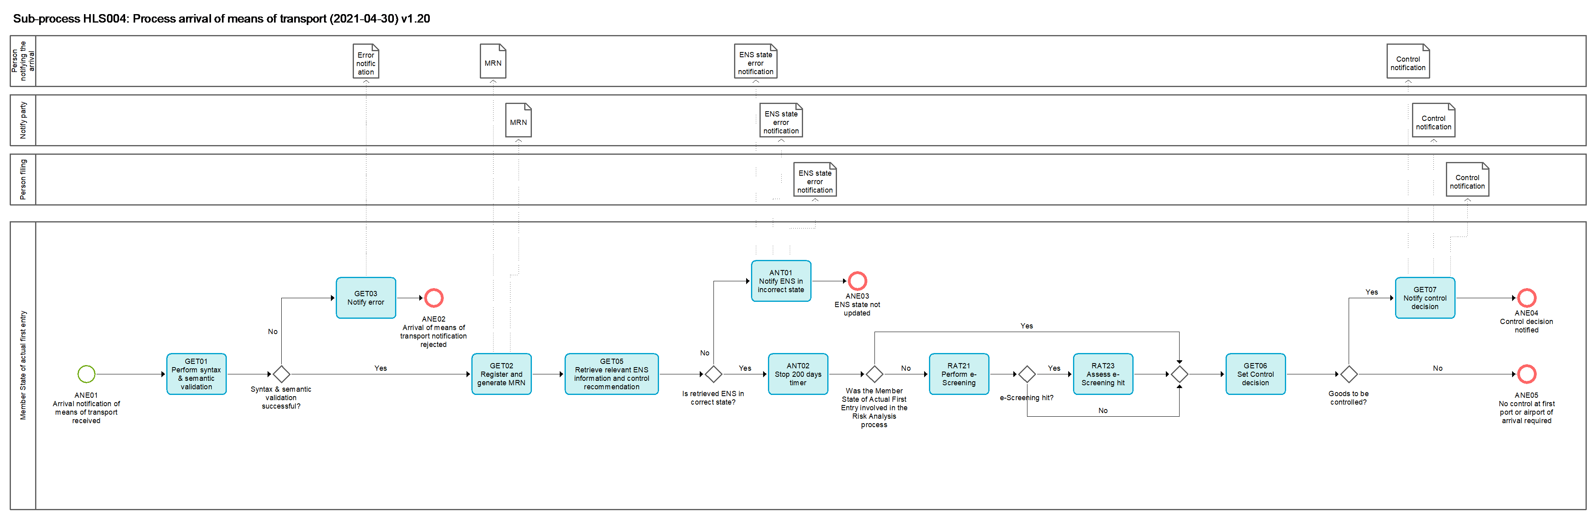
Figure 6: HLS004 Process arrival of the means of transport sub-process

Tasks

GET01 - Perform syntax and semantic validation
Perform syntax and semantic validation | GET01
Organisation: National Customs Administration of Responsible Member State or National Customs Administration of Member State of actual first entry
Input: ENS filing, Arrival notification, Amendment of ENS filing, Invalidation request
Description:
The input file is validated in an automated process. The validation comprises validation of message syntax, checks of the compliance with business rules and conditions as well as reference data.
If the input file is not valid it is rejected;
If the input file is valid it is further processed.
Output (Final situation):
The validation will have the following possible outcomes:
- Successful;
- Unsuccessful, in which case
  - the error description will be generated
  - the input file will obtain the state 'rejected'

GET03 – Notify error
Notify error | GET03
Organisation: National Customs Administration of Responsible Member State or National Customs Administration of Member State of actual first entry
Input: Unsuccessful validation results – containing the error description
Description:
The Arrival notification is not valid and rejected. The person notifying the arrival is notified of the rejection and of the errors that caused the rejection.
Output (Final situation):
The notification of error is generated and sent to the person notifying the arrival and the process ends.

GET02 – Register and generate MRN
Register and generate MRN | GET02
Organisation: National Customs Administration of Responsible Member State or National Customs Administration of Member State of actual first entry
Input: Arrival notification
Description:
Valid Arrival notification is registered, an MRN is generated and allocated to the received Arrival notification. The person notifying the arrival and the notify party, if any, is notified of the registration and the MRN which was allocated to the Arrival notification.
Output (Final situation):
The Arrival notification was registered and MRN has been generated.
The person notifying the arrival and the notify party (where applicable) has been notified.
The Arrival notification obtains the state 'registered'.

GET05 – Retrieve relevant ENS information and control recommendation
Retrieve relevant ENS information and control recommendation | GET05
Organisation: National Customs Administration of the Member State of actual first entry and/or presentation
Input: Registered Arrival notification or Presentation notification
Description:
ENS data related to the given journey of the means of transport for which the arrival has been notified is to be retrieved in an automated process.
To match ENS data with the means of transport the following data elements are used depending on the mode of transport:
- Maritime: The IMO-number and the estimated date and time of arrival at the first place of arrival in the Customs territory of the Union.
- Air: The flight number and the estimated date and time of arrival at the first place of arrival in the Customs territory of the Union or alternatively by a list of MAWB numbers covered by related ENS data
- Independently from the mode of transport a list of MRNs allocated to the related ENS.
The arrival can only be notified once when the means of transport has arrived at the first port/airport in the EU. The status of the related ENS needs to be in a state which is prior to the arrival of the means of transport (prior to an arrival notification received for the means of transport). The related ENS will obtain the state 'arrived' after this task is executed. If the ENS is not in a correct state it will not be further processed.
In case of the split shipments the ENS will obtain the state 'partially arrived'.
In case of a Presentation notification the related ENS will be matched by the MRN of the ENS (or the MRN of a partial ENS filing) referred to in the presentation notification. For air and maritime transport the ENS has to be in state 'arrived' or a later state before actions upon presentation can be processed.
Output (Final situation):
In case of an arrival notification the ENS obtains the state 'arrived' or 'partially arrived'.
In case of Presentation notification the ENS obtains the state 'presented'.

ANT01 – Notify ENS data is in incorrect state
Notify ENS data is in incorrect state | ANT01
Organisation: National Customs Administration of the Member State of actual first entry
Input: Retrieved ENS which is in incorrect state
Description:
A notification to the person notifying the arrival and the notify party, if any, and the person filing (in case of maritime) is generated informing that ENS is in incorrect state and cannot obtain the state 'arrived'.
Output (Final situation):
Person notifying the arrival and the notify party, if any, and person filing (in case of maritime) are notified that ENS in incorrect state and did not obtain the state 'arrived'.

ANT02 – Stop 200 days timer
Stop 200 days timer | ANT02
Organisation: National Customs Administration of the Member State of actual first entry
Input: Retrieved ENS which is in correct state
Description:
The 200 days timer is stopped.
Output (Final situation):
The 200 days timer is stopped.

GET06 – Set control decision
Issue control decision | GET06
Organisation: National Customs Administration of Member State of first entry or presentation or control (at final destination)
Input: Received control recommendation from RMS
Description
The Member State of first entry or presentation or control (at final destination) decides on whether a control is performed or not and if a control is performed on the type of control taking into account the recommendation received from RMS.
Output (Final situation):
Control decision is issued.

GET07 – Notify control decision
Notify control decision | GET07
Organisation: National Customs Administration of the Member State of actual first entry or presentation or control (at final destination)
Input: Control recommendation from RMS or own e-Screening results
Description:
Control decisions for the identified items are notified to the person notifying the arrival, the notify party, if any, and the person filing (in case of maritime). In case of arrival this will force the unloading of the selected items in order to make them available to customs for physical controls even when the unloading of those items at this place was originally not foreseen by that person.
Output (Final situation):
The control decision for items which require a control upon entry is notified to the person notifying the arrival, the notify party, if any, and the person filing (in case of maritime).

Events

ANE01 – Arrival notification is received
Arrival notification is received | ANE01
Organisation: National Customs Administration of the Member State of actual first entry
Arrival notification is received.

ANE02 – Arrival notification is rejected
Arrival notification is rejected | ANE02
Organisation: National Customs Administration of the Member State of actual first entry
Arrival notification is rejected.

ANE03 – Arrival notification is rejected by the National Customs Administration in Responsible Member State
ENS state not updated | ANE03
Organisation: National Customs Administration of the Member State of actual first entry
The process ends after the person notifying the arrival was informed that ENS was in incorrect state.

ANE04 – Control decision notified
Control decision notified | ANE04
Organisation: National Customs Administration of the Member State of actual first entry
Notification to the person notifying the arrival and the notify party, if any, that notified items have to be made available for control at the first port or airport in the EU. The process ends.

ANE05 – No control at the first port or airport required
No control at the first port or airport required | ANE05
Organisation: National Customs Administration of the Member State of actual first entry
The process ends after the task issue control decision where no immediate control at the first port or airport in the EU was decided.

HLS005 – Process presentation and controls
Process presentation and controls | HLS005
Organisation: National Customs Administration of Member State of presentation and control
Input: Received Presentation notification
Description:
The presentation of the goods triggers the controls recommended by the risk analyst of the RMS. Related ENSs to the presented goods are retrieved, the control decisions issued and, where not otherwise decided, the controls are performed and documented.
Output (Final situation):
Goods were presented and in case of an issued control decision also controlled. The sub-process ends.

Business Process Model
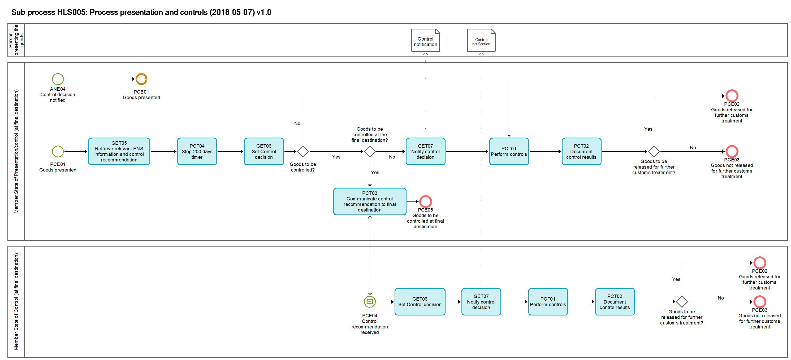
Figure 7: HLS005 Process presentation and controls sub-process

GET05 – Retrieve relevant ENS information and control recommendation
Retrieve relevant ENS information and control recommendation | GET05
Organisation: National Customs Administration of the Member State of actual first entry and/or presentation
Input: Registered Arrival notification or Presentation notification
Description:
ENS data related to the given journey of the means of transport for which the arrival has been notified is to be retrieved in an automated process.
To match ENS data with the means of transport the following data elements are used depending on the mode of transport:
- Maritime: The IMO-number and the estimated date and time of arrival at the first place of arrival in the Customs territory of the Union.
- Air: The flight number and the estimated date and time of arrival at the first place of arrival in the Customs territory of the Union or alternatively by a list of MAWB numbers covered by related ENS data
- Independently from the mode of transport a list of MRNs allocated to the related ENS.
The arrival can only be notified once when the means of transport has arrived at the first port/airport in the EU. The status of the related ENS needs to be in a state which is prior to the arrival of the means of transport (prior to an arrival notification received for the means of transport). The related ENS will obtain the state 'arrived' after this task is executed. If the ENS is not in a correct state it will not be further processed.
In case of the split shipments the ENS will obtain the state 'partially arrived'.
In case of a Presentation notification the related ENS will be matched by the MRN of the ENS (or the MRN of a partial ENS filing) referred to in the presentation notification. For air and maritime transport the ENS has to be in state 'arrived' or a later state before actions upon presentation can be processed.
Output (Final situation):
In case of an arrival notification the ENS obtains the state 'arrived' or 'partially arrived'.
In case of Presentation notification the ENS obtains the state 'presented'.

PCT04 – Stop 200 days timer
Stop 200 days timer | PCT04
Organisation: National Customs Administration of the Member State of presentation
Input: Retrieved ENS which is in correct state
Description:
The 200 days timer is stopped.
Output (Final situation):
The 200 days timer is stopped.

GET06 – Set control decision
Issue control decision | GET06
Organisation: National Customs Administration of Member State of first entry or presentation or control (at final destination)
Input: Received control recommendation from RMS
Description
The Member State of first entry or presentation or control (at final destination) decides on whether a control is performed or not and if a control is performed on the type of control taking into account the recommendation received from RMS.
Output (Final situation):
Control decision is issued.

GET07 – Notify control decision
Notify control decision | GET07
Organisation: National Customs Administration of the Member State of actual first entry or presentation or control (at final destination)
Input: Control recommendation from RMS or own e-Screening results
Description:
Control decisions for the identified items are notified to the person filing the arrival or presentation notification. In case of arrival this will force the presentation of the selected items to customs in order to make them available for physical controls even when the presentation of those items at this place was originally not foreseen by that person.
Output (Final situation):
The control decision for items which require a control upon entry is notified to the person filing.

PCT01 – Perform controls
Perform controls | PCT01
Organisation: National Customs Administration of the Member State of presentation or control
Input: Issued control decision
Description:
Controls are performed as decided in task GET06.
Output (Final situation):
The controls were performed as decided.

PCT02 – Document control results
Document control results | PCT02
Organisation: National Customs Administration of the Member State of presentation or control
Input: Control results
Description:
The results of the performed controls are documented.
Output (Final situation):
The control results are documented.

PCT03 – Communicate control recommendation to final destination
Communicate control recommendation to final destination | PCT03
Organisation: National Customs Administration of the Member State of control
Input: Issued control decision
Description:
The control recommendation is communicated to the Member State of control (at final destination) when different from the Member State where the goods were presented first after their entry into the customs territory of the European Union. This provides the opportunity to perform the controls at the most appropriate place and not necessarily at the border customs office.
Output (Final situation):
The issued control recommendation was communicated to the Member State of control (at final destination).

Events

ANE04 – Control decision notified
Control decision notified | ANE04
Organisation: National Customs Administration of the Member State of actual first entry
Notification to the person filing that notified items have to be made available for control at the first port or airport in the EU. The process ends.

PCE01 – Goods presented
Goods presented | PCE01
Organisation: National Customs Administration of the Member State of presentation
Goods are presented.

PCE02 – Goods released for further customs treatment
Goods released for further customs treatment | PCE02
Organisation: National Customs Administration of the Member State of presentation or control (at final destination)
Goods are released for further customs treatment. The sub-process ends.

PCE03 – Goods not released for further customs treatment
Goods not released for further customs treatment | PCE03
Organisation: National Customs Administration of the Member State of presentation or control (at final destination)
Goods are not released for further customs treatment. The sub-process ends.

PCE04 – Control recommendation received
Control recommendation received | PCE04
Organisation: National Customs Administration of the Member State of control (at final destination)
Control recommendation from Member State of presentation was received by the Member State of control (at final destination).

PCE05 – Goods to be controlled at final destination
Goods to be controlled at final destination | PCE05
Organisation: National Customs Administration of the Member State of presentation
Member State of presentation decided to forward the control recommendation to the Member State of control (at final destination). The sub-process ends.

HLS006 – Amend ENS filing
Amend ENS filing | HLS006
Organisation: National Customs Administration of Responsible Member State
Input: Amendment of ENS filing
Description:
An original ENS filing can be amended by an amendment filing which refers to the original filing by its MRN.
Output (Final situation):
The ENS filing is amended and processed again with the amended data depending on the lifecycle of the original ENS. The sub-process ends.

Business Process Model
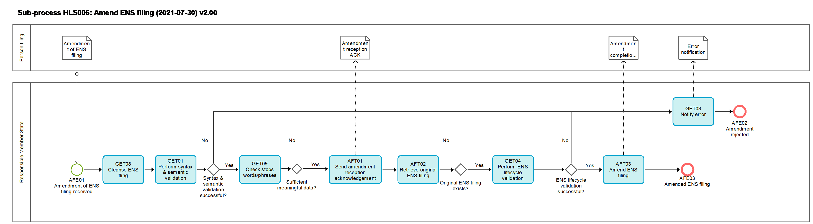
Figure 8: HLS006 Amend ENS filing sub-process

Tasks

GET01 – Perform syntax and semantic validation
Perform syntax and semantic validation | GET01
Organisation: National Customs Administration of Responsible Member State or National Customs Administration of Member State of actual first entry
Input: ENS filing, Arrival notification, Amendment of ENS filing, Invalidation request
Description:
The input file is validated in an automated process. The validation comprises validation of message syntax, checks of the compliance with business rules and conditions as well as reference data.
If the input file is not valid it is rejected;
If the input file is valid it is further processed.
Output (Final situation):
The validation will have the following possible outcomes:
- Successful;
- Unsuccessful, in which case
  - the error description will be generated
  - the input file will obtain the state 'rejected'

AFT01 – Send amendment reception acknowledgement
Send amendment reception acknowledgement | AFT01
Organisation: National Customs Administration of Responsible Member State
Input: Amendment of ENS filing
Description:
A notification is generated and sent to the person filing. This informs about successful syntax and semantic validation.
Output (Final situation):
The person filing the amendment is notified that its amendment passed syntax and semantic validation successfully.

AFT02 – Retrieve original ENS filing
Retrieve original ENS filing | AFT02
Organisation: National Customs Administration of Responsible Member State
Input: Amendment of ENS filing
Description:
The original ENS filing related to the amendment is to be retrieved.
When the original ENS filing can be retrieved, the sub-process continues.
Else the amendment is rejected.
Output (Final situation):
The original ENS filing was retrieved.

GET04 – Perform ENS -lifecycle validation
Perform ENS lifecycle validation | GET04
Organisation: National Customs Administration of Responsible Member State
Input: ENS filing, Amendment of ENS filing, or Invalidation request
Description
The ENS lifecycle validation checks
- Whether the ENS filing is in the correct state regarding the ENS lifecycle’s sequence of the process (E.g. whether an ENS filing refers to a journey of a means of transport which arrived already in the past, or the goods covered by the ENS filing were already presented to the customs and effectively the ENS cannot be filed for the same goods already presented, or ENS cannot be amended or invalidated) and;
- Whether relevant key data; in particular data elements which are used as a unique linking key are unique. In the case of indicated split shipments (i.e. ENS filing containing defined split shipment code indicator) where unique linking key data can be re-used for the remaining goods after the shipment was split, the ENS filing will be processed.
For an ENS amendment;
- That the state of the original ENS filing is not 'presented' or at a state where, for example amendment of the ENS filing is not possible anymore (i.e. customs decided to perform controls, or trader notified by the customs that goods are to be controlled).
- That no particulars were amended which are not allowed to be amended.
- The person filing the amendment needs to be the declarant or the representative of the ENS filing referred to.
For an invalidation request;
- The related ENS filing is required to be in a state prior to the state 'presented'.
- The person filing the invalidation request needs to be the declarant or the representative of the ENS filing referred to.

If the ENS lifecycle validation is successful, the input file obtains the state 'accepted' and the sub-process continues.
If the ENS lifecycle validation fails the input file obtains the state 'rejected' and the sub-process ends.
Output (Final situation):
The state of the input file will either be changed to 'accepted' or 'rejected'.

GET03 – Notify error
Notify error | GET03
Organisation: National Customs Administration of Responsible Member State
Input: Unsuccessful validation results – containing the error description
Description:
The file is not valid and rejected. The person filing is notified of the rejection and of the errors that caused the rejection.
Output (Final situation):
The notification of error is generated and sent to the person filing and the process ends.

AFT03 – Amend ENS filing
Amend ENS filing | AFT03
Organisation: National Customs Administration of Responsible Member State
Input: Accepted ENS filing amendment
Description:
The original ENS filing is amended and processed again with the amended data depending on the state of the original ENS. The risk analysis will be re-performed with the amended data.
Output (Final situation):
The original ENS filing is amended.

GET08 – Cleanse ENS filling
Cleanse ENS filling | GET08
Organisation: National Customs Administration of Responsible Member State
Input: ENS filing, Amendment of ENS filing
Description
The cleansing of the ENS data removes symbols and strings from the ENS filing according the common predefined rules agreed with the Member states.
The cleansed version of the ENS filing is stored (and the non-cleansed for the purpose of enrichment) and the sub-process continues.
Output (Final situation):
The cleansed version of the ENS filing is stored.

GET09 – Check stop words/phrases
Check stop words/phrases | GET09
Organisation: National Customs Administration of Responsible Member State
Input: ENS filing, Amendment of ENS filing
Description
The input cleansed version of the ENS filing is checked against the pre-defined stop words/phrases per data element. In case the data element contains only stop words/phrases it is considered empty and, if the data element is mandatory, the ENS filing is rejected due to poor data quality.
The stop words/phrases are not removed from the data elements of the ENS filing.
If the validation is successful, the ENS filing the state 'accepted' and the sub-process continues.
If the validation fails the ENS filing obtains the state 'rejected' and the sub-process ends.
Output (Final situation):
The state of the ENS filing will be either changed to 'accepted' or to 'rejected' due to insufficient data quality.

Events

AFE01 – Amendment of ENS filing received
Amendment of ENS filing received | AFE01
Organisation: National Customs Administration of a Responsible Member State
An amendment of an original ENS filing is received.

AFE02 – Amendment rejected
Amendment rejected | AFE02
Organisation: National Customs Administration of Responsible Member State
Amendment is rejected. The sub-process ends.

AFE03 – Amended ENS filing
Amended ENS filing | AFE03
Organisation: National Customs Administration of Responsible Member State
The original ENS filing was amended. The sub-process ends.

HLS007 – Invalidate filing
Invalidate filing | HLS007
Organisation: National Customs Administration of Responsible Member State
Input: Accepted invalidation request file or 200 days timer expiry.
Description:
The ENS filing for which the 200 days timer expired or the ENS filing referred to in the invalidation request will be invalidated by assigning the status 'invalidated'.
Output (Final situation):
The ENS filing is no longer processed and will be moved to an archive. The sub-process ends.

Business Process Model
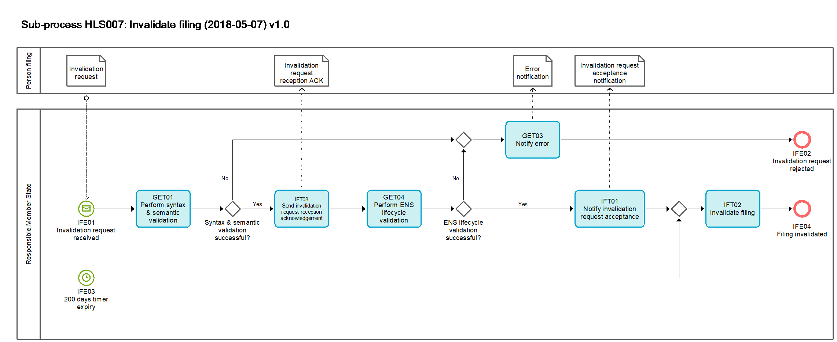
Figure 9: HLS007 Invalidate filing sub-process

Tasks

GET01 – Perform syntax and semantic validation
Perform syntax and semantic validation | GET01
Organisation: National Customs Administration of Responsible Member State or National Customs Administration of Member State of actual first entry
Input: ENS filing, Arrival notification, Amendment of ENS filing, Invalidation request
Description:
The input file is validated in an automated process. The validation comprises validation of message syntax, checks of the compliance with business rules and conditions as well as reference data.
If the input file is not valid it is rejected;
If the input file is valid it is further processed.
Output (Final situation):
The validation will have the following possible outcomes:
- Successful;
- Unsuccessful, in which case
  - the error description will be generated
  - the input file will obtain the state 'rejected'

GET03 – Notify error
Notify error | GET03
Organisation: National Customs Administration of Responsible Member State or National Customs Administration of Member State of actual first entry
Input: Unsuccessful validation results – containing the error description
Description:
The file is not valid and rejected. The person filing is notified of the rejection and of the errors that caused the rejection.
Output (Final situation):
The notification of error is generated and sent to the person filing and the process ends.

IFT03 – Send invalidation request reception acknowledgement
Send invalidation request reception acknowledgement | AFT01
Organisation: National Customs Administration of Responsible Member State
Input: Invalidation request
Description:
A notification is generated and sent to the person filing. This informs about successful syntax and semantic validation.
Output (Final situation):
The person filing is notified that its invalidation request passed syntax and semantic validation successfully.

GET04 – Perform ENS-lifecycle validation
Perform ENS lifecycle validation | GET04
Organisation: National Customs Administration of Responsible Member State
Input: ENS filing, Amendment of ENS filing, or Invalidation request
Description
The ENS lifecycle validation checks
- Whether the ENS filing is in the correct state regarding the ENS lifecycle’s sequence of the process (E.g. whether an ENS filing refers to a journey of a means of transport which arrived already in the past, or the goods covered by the ENS filing were already presented to the customs and effectively the ENS cannot be filed for the same goods already presented, or ENS cannot be amended or invalidated) and;
- Whether relevant key data; in particular data elements which are used as a unique linking key are unique. In the case of indicated split shipments (i.e. ENS filing containing defined split shipment code indicator) where unique linking key data can be re-used for the remaining goods after the shipment was split, the ENS filing will be processed.
For an ENS amendment;
- That the state of the original ENS filing is not 'presented' or at a state where, for example amendment of the ENS filing is not possible anymore (i.e. customs decided to perform controls, or trader notified by the customs that goods are to be controlled).
- That no particulars were amended which are not allowed to be amended.
- The person filing the amendment needs to be the declarant or the representative of the ENS filing referred to.
For an invalidation request;
- The related ENS filing is required to be in a state prior to the state 'presented'.
- The person filing the invalidation request needs to be the declarant or the representative of the ENS filing referred to.

If the ENS lifecycle validation is successful, the input file obtains the state 'accepted' and the sub-process continues.
If the ENS lifecycle validation fails the input file obtains the state 'rejected' and the sub-process ends.
Output (Final situation):
The state of the input file will either be changed to 'accepted' or 'rejected'.

IFT01 – Notify invalidation request acceptance
Notify invalidation request acceptance | IFT01
Organisation: National Customs Administration of Responsible Member State
Input: Invalidation request
Description:
Notification of acceptance of the invalidation request is generated and sent to the person filing and the process continues.
Output (Final situation):
The person filing is notified of the acceptance of the invalidation request.

IFT02 – Invalidate filing
Invalidate filing | IFT02
Organisation: National Customs Administration of Responsible Member State
Input: Invalidation request or 200 days timer expiry.
Description:
The ENS filing for which the 200 days timer expired or the ENS filing referred to in the invalidation request will be invalidated by assigning the status 'invalidated'.
Output (Final situation):
The ENS filing is no longer processed and will be moved to an archive.

Events

IFE01 – Invalidation request received
Invalidation request received | IFE01
Organisation: National Customs Administration of a Responsible Member State
An invalidation request is received.

IFE02 – Invalidation request is rejected
Invalidation request is rejected | IFE02
Organisation: National Customs Administration of Responsible Member State
Invalidation request is rejected. The sub-process ends.

IFE03 – 200 days timer expiry
200 days timer expiry | IFE03
Organisation: National Customs Administration of a Responsible Member State
The 200 days timer which was started after registration of ENS filing has expired.

IFE04 – Filing invalidated
Filing invalidated | IFE04
Organisation: National Customs Administration of Responsible Member State
The filing was invalidated. The sub-process ends.

Events

HLE01 – ENS filing received
ENS filing received | HLE01
Organisation: National Customs Administration of the Responsible Member State
A person filing lodges an ENS filing.

HLE02 – Amendment of ENS filing received
Amendment of ENS filing received | HLE02
Organisation: National Customs Administration of the Responsible Member State
A person filing lodges an amendment for an already lodged ENS filing.

HLE03 – Invalidation request received
Invalidation request received | HLE03
Organisation: National Customs Administration of a Responsible Member State
An invalidation request is received.

HLE04 – 200 days timer expiry
200 days timer expiry | HLE04
Organisation: National Customs Administration of a Responsible Member State
The 200 days timer which was started after registration of the ENS filing has expired.

HLE05 – ENS filing invalidated
ENS filing invalidated | HLE05
Organisation: National Customs Administration of Responsible Member State
The filing was invalidated. The process ends.

HLE06 – Entry process completed
Entry process completed | HLE06
Organisation: National Customs Administration of the Responsible Member State
The entire entry process is completed.

HLE07 – Arrival notification received
Arrival notification received | HLE07
Organisation: National Customs Administration of the Member State of actual first entry
Arrival notification is received.

HLE08 – Arrival notification processed
Arrival notification processed | HLE08
Organisation: National Customs Administration of the Member State of actual first entry
Arrival notification was processed.

HLE09 – Goods presented
Goods presented | HLE09
Organisation: National Customs Administration of the Member State of presentation and/or control
The person presenting the goods presents the goods to the Member State of control.

HLE10 – Goods presented and controlled
Goods presented and controlled | HLE10
Organisation: National Customs Administration of the Member State of presentation and/or control
Control of goods was performed and control results were documented.

Main entities & State transitions
The ICS2 comprises several entities which interact with each other through the different ICS2 sub-processes. In this chapter, the entities with the most significant role in the process of entry of goods will be introduced and described.
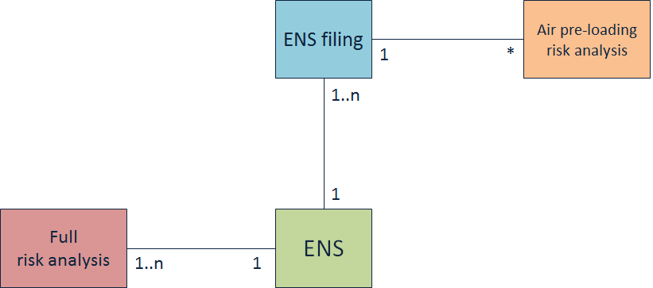
Figure 10: Main entities
An ENS is constructed with either single or multiple ENS filing(s).
The ENS filings that contain one or more PLACI dataset(s) will have a pre-loading risk analysis performed on each of those datasets.
When an ENS is considered complete, meaning that all expected ENS filings have been received from the different involved parties, a full risk analysis will be performed on that ENS. There might be more than one full risk analysis performed on an ENS, in the case of parts of the ENS were amended.

State transition diagram
This diagram (Figure 12) presents the state transitions that each of the aforementioned main ICS2 entities can go through. The Figure 11 explains the notation used in the state transitions diagram.
For the facilitation of the reader, the sub-processes and the specific events and tasks that might trigger a state change in any of the entities are also depicted. The sub-processes, tasks and events that are referenced here are described in Chapter High level end-to-end process.
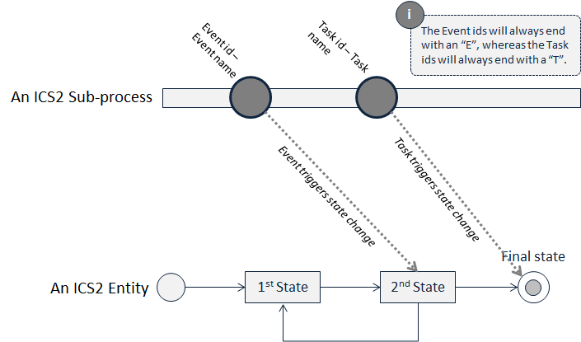
Figure 11: State transition example

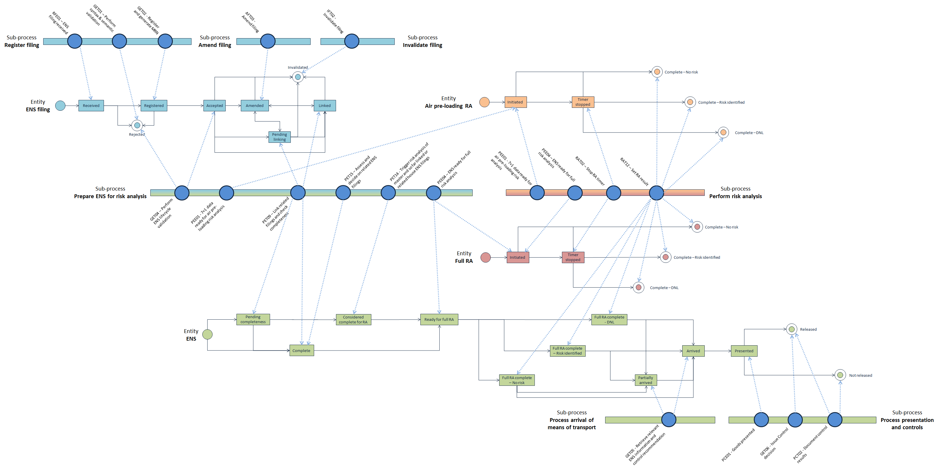
Figure 12: State transition diagram

Annex

ENS filing types
F10 | Sea and inland waterways – Complete dataset – Straight bill of lading containing the necessary information from consignee
F11 | Sea and inland waterways – Complete dataset – Master bill of lading with underlying house bill(s) of lading containing the necessary information from consignee at the level of the lowest house bill of lading
F12 | Sea and inland waterways – Partial dataset – Master bill of lading only
F13 | Sea and inland waterways – Partial dataset – Straight bill of lading only
F14 | Sea and inland waterways – Partial dataset – House bill of lading only
F15 | Sea and inland waterways – Partial dataset – House bill of lading with the necessary information from consignee
F16 | Sea and inland waterways – Partial dataset – Necessary information required to be provided by consignee at the lowest level of transport contract (straight bill or the lowest house bill of lading)
F20 | Air cargo (general) – Complete dataset lodged pre-loading
F21 | Air cargo (general) – Partial dataset – Master air waybill lodged pre-arrival
F22 | Air cargo (general) – Partial dataset – House air waybill lodged pre-arrival
F23 | Air cargo (general) — Partial dataset — Minimum dataset lodged pre- loading in accordance with Article 106(1) second subparagraph of Delegated Regulation (EU) 2015/2446 without master air waybill reference number
F24 | Air cargo (general) — Partial dataset — Minimum dataset lodged pre- loading in accordance with Article 106(1) second subparagraph of Delegated Regulation (EU) 2015/2446 with master air waybill reference number
F25 | Air cargo (general) — Partial dataset — Master air waybill reference number lodged pre-loading in accordance with Article 106(1) second subparagraph of Delegated Regulation (EU) 2015/2446
F26 | Air cargo (general) — Partial dataset — Minimum dataset lodged pre- loading in accordance with Article 106(1) second subparagraph of Delegated Regulation (EU) 2015/2446 and containing additional house air waybill information
F27 | Air cargo (general) — Complete dataset lodged pre-arrival
F28 | Air cargo (general) — Complete dataset lodged pre-loading – Direct air waybill
F29 | Air cargo (general) — Complete dataset lodged pre-arrival – Direct air waybill
F30 | Express consignments — Complete dataset lodged pre-arrival
F31 | Express consignments on air cargo general – Complete dataset lodged pre-arrival by the express operator
F32 | Express consignments — Partial dataset — Minimum dataset lodged pre-loading in accordance with Article 106(1) second subparagraph of Delegated Regulation (EU) 2015/2446
F33 | Express consignments on air cargo general – Partial dataset – House air waybill lodged pre-arrival by a person pursuant to Article 127(6) of the Code and in accordance with Article 113(1)
F34 | Express consignments on road – Complete dataset lodged pre-arrival
F40 | Postal consignments – Partial dataset – Road Master bill of lading
F41 | Postal consignments – Partial dataset – Rail master transport document information
F42 | Postal consignments – Partial dataset - Master air waybill containing necessary postal air waybill information lodged in accordance with the time-limits applicable for the mode of transport concerned
F43 | Postal consignments — Partial dataset — Minimum dataset lodged pre- loading in accordance with Article 106(1) second subparagraph of Delegated Regulation (EU) 2015/2446
F44 | Postal consignment — Partial dataset — Receptacle identification number lodged pre-loading in accordance with Article 106(1) second subparagraph of Delegated Regulation (EU) 2015/2446
F45 | Postal consignments – Partial dataset – Sea and inland waterways
F50 | Road mode of transport
F51 | Rail mode of transport
F52 | Rail mode of transport – Partial dataset – Rail master transport document information only
F53 | Rail mode of transport – Partial dataset – House level transport document information with the necessary information from consignee
F54 | Rail mode of transport – Partial dataset – House level transport document information only
F55 | Rail mode of transport – Partial dataset – Necessary information required to be provided by consignee at the lowest level of transport contract

End of document

